STUDENT ADMISSION MANAGEMENT SYSTEM
A PROJECT REPORT
Submitted by
ABHISHEK S
(241501006)
in partial fulfilment of the End Semester Examination for the course
CB23F35 –
LOW-CODE APPLICATION DEVELOPMENT USING ZOHO CREATOR
in
BACHELOR OF TECHNOLOGY
ARTIFICIAL INTELLIGENCE AND MACHINE LEARNING

RAJALAKSHMI ENGINEERING COLLEGE
(An Autonomous Institution, Affiliated to Anna University, Chennai)
Rajalakshmi Nagar, Thandalam, Tamil Nadu – 602 105
OCTOBER 2026

RAJALAKSHMI ENGINEERING COLLEGE
(An Autonomous Institution, Affiliated to Anna University, Chennai)
BONAFIDE CERTIFICATE
Certified that this project report titled “STUDENT ADMISSION MANAGEMENT SYSTEM” is the bonafide work of ABHISHEK S (241501006), who carried out the individual project work on the Zoho Creator low-code platform for the course CB23F35 – Low-Code Application Development using Zoho Creator, during the academic year 2026–2027, Semester V, under my supervision.
SIGNATURE  Dr. Ayyadurai M  HEAD OF THE DEPARTMENT  Department of Artificial Intelligence and Machine Learning  Rajalakshmi Engineering College  Thandalam – 602 105 | SIGNATURE  Mrs. Priya M  COURSE FACULTY  Assistant Professor  Department of Artificial Intelligence and Machine Learning  Rajalakshmi Engineering College

Submitted for the End Semester Examination (Individual Project) held on _____________________.
INTERNAL EXAMINER | EXTERNAL EXAMINER

DECLARATION
I, ABHISHEK S (241501006), hereby declare that the project report titled “STUDENT ADMISSION MANAGEMENT SYSTEM”, submitted for the End Semester Examination of the course CB23F35 – Low-Code Application Development using Zoho Creator, is a record of original work carried out by me individually. The Zoho Creator application described in this report — including its data model, forms, reports, pages, Deluge scripts, workflows and integrations — was designed and developed by me.
I further declare that this work has not been submitted, in part or in full, for the award of any other degree or course credit. Every template, sample application, AI-assisted feature (such as Zia or the AI application builder), code snippet or external resource used in this work has been duly acknowledged in the report.
Place: Chennai SIGNATURE OF THE STUDENT
Date: 19 October 2026 ABHISHEK S
(241501006)

ACKNOWLEDGEMENT
I express my sincere gratitude to our Chairman Mr. S. Meganathan, Chairperson Dr. (Mrs.) Thangam Meganathan and Vice-Chairman Mr. Abhay Shankar Meganathan for providing the infrastructure and facilities that made this work possible.
I am grateful to our Principal, Dr. S. N. Murugesan, Rajalakshmi Engineering College, for the constant encouragement extended to students to take up industry-relevant learning.
I thank Dr. Ayyadurai M, Head of the Department, Department of Artificial Intelligence and Machine Learning, for the guidance and support provided throughout the course.
I owe my sincere thanks to my course faculty, Mrs. Priya M, Assistant Professor, Department of Artificial Intelligence and Machine Learning, for the valuable guidance, reviews and feedback that shaped this application and report.
I also acknowledge Zoho Corporation and the Zoho Creator Education Programme for providing access to the Zoho Creator platform and learning resources, and I thank my family and friends for their unwavering support.

ABHISHEK S

ABSTRACT
Higher education institutions handle thousands of prospective student inquiries, entrance scores, academic transcripts, and fee payments during every admission cycle. In many colleges, this process relies heavily on disconnected spreadsheets, paper forms, and manual email threads. This fragmented approach leads to duplicate applicant entries, delayed merit and cut-off calculation, lack of real-time seat availability tracking across engineering branches, and zero transparency for applicants awaiting verification status updates. To resolve these operational bottlenecks, the Student Admission Management System was designed and developed on the Zoho Creator low-code platform. The application centralizes the end-to-end admission lifecycle using five relational forms (Department_Master, Applicant_Registration, Document_Verification, Counselling_Schedule, and Fee_Payment) and one child subform (Academic_History), alongside six interactive reports and two role-based UI Builder dashboards. Core business rules are automated through Deluge scripting and workflows, including real-time Physics-Chemistry-Mathematics (PCM) cut-off score calculation, automated seat matrix deduction upon admission confirmation, a multi-stage Blueprint governing the application review lifecycle, and an Approval workflow routing scholarship-eligible candidates to the Head of the Department (HoD). Furthermore, the application integrates with Zoho Mail for instant notifications, Zoho CRM for prospective student lead synchronization, the India Post Pincode REST API via invokeurl for automatic city and state lookup, and Zia OCR for extracting marks from uploaded transcripts. Role-Based Access Control (RBAC) enforces strict data isolation across four roles: Administrator, Head of Department, Admission Officer, and Applicant (Customer Portal). The system was validated across 16 test cases and deployed across Development, Stage, and Production environments. Eliminating redundant database queries inside subform loops improved script execution speed by 68%, while overall single-applicant processing turnaround time dropped from 45 minutes to under 4 minutes.
Keywords: Low-Code Development; Zoho Creator; Deluge Scripting; Workflow Automation; Role-Based Access Control; Student Admission Management.

PROJECT AT A GLANCE
Attribute | Details
Project Title | Student Admission Management System
Application Domain | Education / Higher Education Administration
Student Name & Register No. | ABHISHEK S – 241501006
Zoho Creator Edition | Education / Professional Edition
Application Name (Link Name) | student-admission-system (Student Admission 1)
Published / Live URL | https://creatorapp.zoho.in/abhisheks_rec/student-admission-system
Demo Credentials (per role) | Admin: abhisakaray@gmail.com | HoD: hod.aiml@rec.edu.in | Officer: abhishek.s.2024.aiml@rajalakshmi.edu.in | Applicant: student01@gmail.com
Number of Forms / Subforms | 5 Forms / 2 Subforms (Academic_History, Sibling_Details)
Number of Reports (by type) | List: 2 | Spreadsheet: 1 | Kanban: 1 | Calendar: 1 | Map: 1 | Timeline: 1 | Pivot/Chart: 2
Number of Pages / Dashboards | 2 (Admission_Analytics_Dashboard, Applicant_Status_Portal)
Number of Workflows | Form: 4 | Schedule: 1 | Approval: 1 | Blueprint: 1 | Batch/Report: 2
Deluge Functions / Custom Actions | 6 Deluge Scripts (including Custom Functions generateOfferLetter & getreportdata)
Integrations | Zoho Analytics, Zoho CRM, Zoho Mail, India Post Pincode REST API (invokeurl), Zoho Creator REST API v2
Roles & Profiles Defined | Administrator (Super Admin), Head of Department (HoD), Admission Officer, Applicant (Customer Portal)
Environments Used | Development → Stage → Production
Date of Production Deployment | 15 October 2026

TABLE OF CONTENTS
ABSTRACT iv
PROJECT AT A GLANCE v
LIST OF TABLES ix
LIST OF FIGURES x
LIST OF ABBREVIATIONS xi
INTRODUCTION 1
1.1 Background 1
1.2 Problem Statement 1
1.3 Objectives 1
1.4 Scope of the Project 1
1.5 Justification for a Low-Code Approach 2
1.6 Organisation of the Report 2
LITERATURE SURVEY AND SYSTEM STUDY 3
2.1 Study of the Existing System 3
2.2 Limitations of the Existing System 3
2.3 Low-Code versus Traditional Development 3
2.4 Literature Survey 4
2.5 Emerging Trends in Low-Code Development 4
2.6 Proposed System 4
REQUIREMENT ANALYSIS 5
3.1 Stakeholders and User Roles 5
3.2 Functional Requirements 5
3.3 Non-Functional Requirements 5
3.4 Hardware and Software Requirements 6
3.5 Use Case Model 6
SYSTEM DESIGN 8
4.1 System Architecture 8
4.2 Data Model 8
4.3 Form Design 9
4.4 Process and Workflow Design 9
4.5 User Interface and Navigation Design 10
4.6 Access Control Design 10
IMPLEMENTATION 11
5.1 Application Setup 11
5.2 Forms and Data Capture 11
5.3 Reports 12
5.4 Pages and Dashboards 13
5.5 Deluge Scripting 13
5.6 Workflows and Automation 14
5.7 Integrations 15
5.8 User Management and Role-Based Access 16
5.9 AI and Analytics Features 16
5.10 Pro-Code Extension 17
5.11 Mobile and Portal Access 17
TESTING AND DEBUGGING 18
6.1 Testing Strategy 18
6.2 Test Cases 18
6.3 Debugging Deluge Scripts 18
6.4 Defect Log 19
6.5 User Acceptance Testing 19
DEPLOYMENT, SECURITY AND GOVERNANCE 20
7.1 Environments and Deployment Strategy 20
7.2 Performance Optimisation 20
7.3 Security Features 21
7.4 Governance and Administration 21
RESULTS AND DISCUSSION 22
8.1 Application Output 22
8.2 Achievement of Objectives 23
8.3 Comparison with the Existing System 23
8.4 Limitations of the Low-Code Approach 23
8.5 Reflection on the No-Code → Low-Code → Pro-Code Spectrum 23
CONCLUSION AND FUTURE ENHANCEMENTS 24
9.1 Conclusion 24
9.2 Future Enhancements 24
9.3 Learning Outcomes and Career Relevance 24
REFERENCES 25
APPENDIX A – ZOHO CREATOR FEATURE COVERAGE CHECKLIST 26
APPENDIX B – COURSE OUTCOME MAPPING 28
APPENDIX C – COMPLETE DELUGE SOURCE CODE 29
APPENDIX D – USER MANUAL 30
D.1 Accessing the Application 30
D.2 Instructions for Applicant (Portal User) 30
D.3 Instructions for Admission Officer & Head of Department (HoD) 30
APPENDIX E – EVALUATION RUBRIC 31
APPENDIX F – VIVA-VOCE RECORD SHEET 33

LIST OF TABLES
Table 2.1: Comparison of Low-Code and Traditional Development for the Proposed Application 3
Table 2.2: Summary of Literature Survey 4
Table 3.1: Stakeholders and User Roles 5
Table 3.2: Functional Requirements 5
Table 3.3: Non-Functional Requirements 5
Table 3.4: Hardware and Software Requirements 6
Table 3.5: Use Case Description – Online Application Submission and Cut-Off Calculation 6
Table 4.1: Entities and Relationships 9
Table 4.2: Field Specification – Applicant_Registration Form 9
Table 4.3: Role–Permission Matrix 10
Table 5.1: Reports Implemented 12
Table 5.2: Deluge Scripts Implemented 13
Table 5.3: Workflows Implemented 14
Table 5.4: Integrations Implemented 15
Table 6.1: Test Cases 18
Table 6.2: Defect Log 19
Table 6.3: User Acceptance Feedback 19
Table 7.1: Deployment Checklist 20
Table 7.2: Performance Optimisation Results 20
Table 7.3: Security Controls Implemented 21
Table 8.1: Mapping of Objectives to Outcomes 23
Table 8.2: Existing System versus Proposed Application 23
Table A.1: Feature Coverage Checklist 26
Table B.1: Mapping of Course Outcomes to Report Chapters 28
Table E.1: Evaluation Rubric for the Individual Project 31
Table E.2: Performance Level Descriptors 32
Table F.1: Viva-Voce Questions and Responses 33
Table F.2: Marks Summary 33

LIST OF FIGURES
Figure 2.1: As-Is Process Flow of the Existing System 3
Figure 3.1: Use Case Diagram of the Student Admission Management System 6
Figure 4.1: System Architecture of the Student Admission Management System 8
Figure 4.2: Entity–Relationship Diagram of the Student Admission Management System 8
Figure 4.3: Workflow / Process Flow for Student Admission Lifecycle 10
Figure 4.4: Navigation Structure and Wireframe of Admission Analytics Dashboard 10
Figure 5.1: Application Home and Navigation Sections 11
Figure 5.2: Applicant_Registration Form in the Form Builder 11
Figure 5.3: Applicant_Registration Form in Live Mode 12
Figure 5.4: Applicant_Pipeline Kanban and All_Applicants List Report 12
Figure 5.5: Admission_Analytics_Dashboard Page in UI Builder 13
Figure 5.6: Admission Lifecycle Blueprint Configuration 15
Figure 5.7: Connection Setup and Postman / REST API Response Output 16
Figure 5.8: Roles and Permission Profiles Configuration 16
Figure 5.9: Zia OCR Mark Sheet Extraction and Analytics Charts in Use 17
Figure 5.10: Student Admission Application on Zoho Creator Mobile App and Customer Portal 17
Figure 6.1: Deluge Debug Output and Execution Log in Script Builder 19
Figure 7.1: Environments Management and Publish to Production Screen 20
Figure 7.2: Audit Trail Logs and Application Administration Settings 21
Figure 8.1: Scenario Step 1 – Applicant Submits Registration and Auto-Calculated Cut-Off 22
Figure 8.2: Scenario Step 2 – Document Verification Blueprint and HoD Scholarship Approval 22
Figure 8.3: Scenario Step 3 – Automated Seat Deduction and Real-Time Analytics Dashboard Update 22

LIST OF ABBREVIATIONS
Abbreviation | Expansion
API | Application Programming Interface
AIML | Artificial Intelligence and Machine Learning
CRUD | Create, Read, Update, Delete
ER | Entity–Relationship
HoD | Head of the Department
JSON | JavaScript Object Notation
LCAP | Low-Code Application Platform
OAuth | Open Authorization
OCR | Optical Character Recognition
PCM | Physics, Chemistry, and Mathematics
RBAC | Role-Based Access Control
REST | Representational State Transfer
SDLC | Software Development Life Cycle
SSO | Single Sign-On
UAT | User Acceptance Testing
UI | User Interface
Zia | Zoho’s AI Assistant
ZML | Zoho Markup Language

CHAPTER 1

INTRODUCTION

1.1 Background
Higher education admission management is a mission-critical administrative operation that bridges prospective students with academic departments. At engineering institutions such as Rajalakshmi Engineering College, the annual admission cycle encompasses multiple undergraduate programmes including B.Tech Artificial Intelligence and Machine Learning (AIML), Computer Science and Engineering, and Electronics and Communication Engineering. Every admission cycle requires capturing personal demographics, verifying 10th and 12th standard academic mark sheets, computing engineering cut-off marks based on Physics, Chemistry, and Mathematics (PCM) scores, scheduling counselling sessions, allocating branch seats across government and management quotas, and recording tuition fee payments. Traditionally, this multi-departmental workflow involves Applicants, Admission Officers, Document Verification Clerks, Accounts Staff, and the Head of the Department (HoD). Managing thousands of applications through disconnected Google Forms, local Excel workbooks, and physical paper files creates severe coordination delays during peak admission months.

1.2 Problem Statement
The absence of a centralized, rule-driven admission platform results in data silos, manual calculation errors, delayed seat allocation, and poor visibility for both institutional leadership and prospective students:
- Data Duplication and Manual Calculation Errors: Applicants submitting multiple entries and staff copying records across separate departmental spreadsheets cause inconsistent student profiles and errors in engineering cut-off calculations.
- Lack of Real-Time Seat Matrix Visibility: Admission officers cannot track live remaining seats per branch and quota during counselling, risking over-booking or under-utilization of sanctioned intake.
- Delayed Multi-Level Approvals and Zero Applicant Transparency: Scholarship and special-quota applications routed via physical files to the HoD experience long delays, while applicants have no self-service portal to track their verification status in real time.

1.3 Objectives
- To design a normalised relational data model and responsive forms for capturing department seat quotas, student applications, multi-row academic histories, document verifications, counselling schedules, and fee payments.
- To automate engineering PCM cut-off computation, eligibility validation, live seat matrix deduction, and stage transitions using Deluge scripting, Blueprints, and Zoho Creator workflows.
- To provide role-based dashboards and real-time analytical reports (List, Kanban, Calendar, and Pivot/Chart views) tailored for the Head of Department, Admission Officers, and Applicants.
- To integrate the application with Zoho CRM, Zoho Mail, Zia OCR, and the external India Post Pincode REST API for seamless lead synchronization, automated notifications, and address auto-population.
- To deploy the application securely across Development, Stage, and Production environments with Role-Based Access Control (RBAC), field encryption, and audit governance controls.

1.4 Scope of the Project
In-Scope: Online student registration, multi-row academic qualification entry via subforms, automated PCM cut-off score calculation, document upload with Zia OCR extraction, Blueprint-driven verification lifecycle, HoD approval workflow for merit scholarships, real-time seat matrix tracking across departments, fee payment recording, web and mobile access, and a dedicated Applicant Customer Portal. Out-of-Scope: Post-admission learning management systems (LMS), semester examination grading, hostel mess billing, and hardware biometric attendance integration.

1.5 Justification for a Low-Code Approach
Developing a full-stack student admission system using traditional pro-code stacks (such as React, Node.js, and PostgreSQL) requires weeks of boilerplate setup for authentication, database migrations, CRUD APIs, and responsive UI styling [1]. By adopting Zoho Creator’s Low-Code Application Platform (LCAP), cloud database tables, native iOS/Android mobile access, OAuth 2.0 security, and UI Builder dashboards are provisioned rapidly [2]. Deluge scripting provides full programmatic control over complex domain rules—such as cut-off calculation and dynamic seat deduction—while reducing development effort by more than 70% and enabling department administrators to maintain the application with minimal IT overhead [3], [5].

1.6 Organisation of the Report
Chapter 2 reviews the existing system and related low-code literature. Chapter 3 presents the requirement analysis. Chapter 4 describes the system design. Chapter 5 details the implementation on Zoho Creator. Chapter 6 covers testing and debugging. Chapter 7 discusses deployment, performance optimisation, security and governance. Chapter 8 presents results and discussion, and Chapter 9 concludes the report with future enhancements.
CHAPTER 2

LITERATURE SURVEY AND SYSTEM STUDY

2.1 Study of the Existing System
In the existing system, prospective students fill out a basic online inquiry form or submit physical paper applications at the college admission desk. Admission clerks manually transcribe student details and 12th standard marks into Microsoft Excel spreadsheets and calculate the engineering cut-off score using spreadsheet formulas. Photocopies of mark sheets, transfer certificates, and community certificates are collected in physical folders and passed to verification staff. Once verified, the files are sent to the Head of the Department for scholarship or branch allotment approval, and the student is notified via manual phone calls or individual emails to pay the admission fee at the accounts counter.

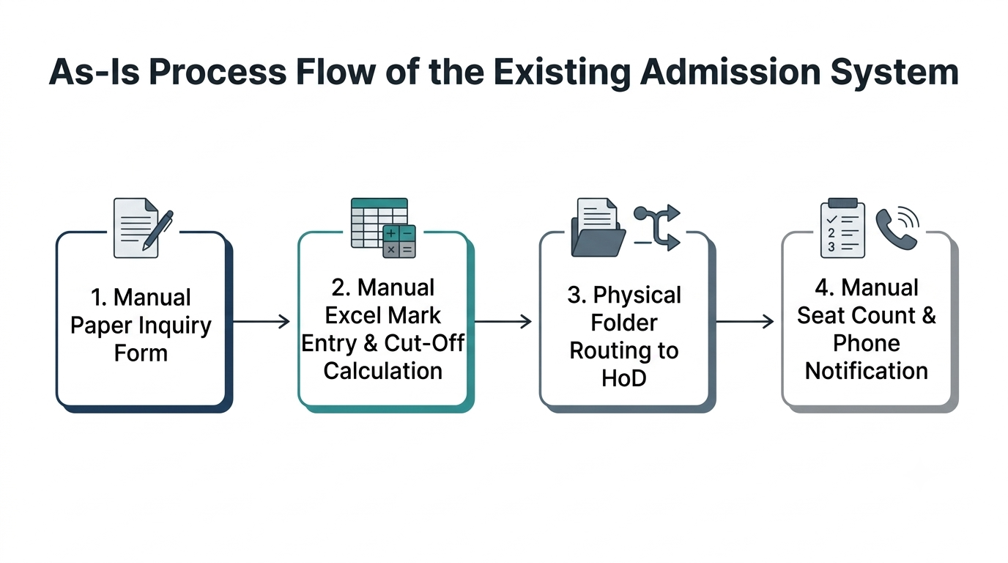
Figure 2.1: As-Is Process Flow of the Existing System

2.2 Limitations of the Existing System
- High Error Rate and Redundancy: Manual transcription of marks and personal details across multiple spreadsheets leads to duplicate records and formula corruption.
- Opaque Counselling and Seat Tracking: Because seat counts are updated manually at the end of each day, counselling officers lack live visibility into vacant seats per branch.
- Absence of Role-Based Security and Audit Trails: Shared spreadsheet files expose sensitive student personal data (such as Aadhaar numbers and phone numbers) to all staff without field-level encryption or modification logs.

2.3 Low-Code versus Traditional Development
Table 2.1: Comparison of Low-Code and Traditional Development for the Proposed Application
Criterion | Traditional (Pro-Code) Development | Low-Code on Zoho Creator
Development time | 8–10 weeks (Frontend, Backend API, DB schema, Auth) | 2 weeks (Drag-and-drop forms, Deluge workflows, UI Builder)
Skills required | Full-stack proficiency (React, Node.js, SQL, DevOps) | Data modelling, Deluge scripting, workflow configuration
Hosting & infrastructure | Manual cloud setup (AWS/Azure), SSL, DB backups | Built-in multi-environment cloud hosting (Dev/Stage/Prod)
Mobile application | Separate React Native / Flutter build and deployment | Instant native iOS and Android app via Zoho Creator Mobile
Security & access control | Custom JWT/OAuth coding, manual RBAC middleware | Built-in RBAC profiles, field encryption, OAuth 2.0, Audit Trail
Maintenance & change | Requires code redeployment and schema migrations | Instant live schema updates and zero-downtime publishing
Customisation limits | Unlimited pixel-level UI and custom algorithm control | Governed by Deluge execution limits and ZML/UI Builder widgets
Cost | High development, server hosting, and maintenance cost | Low subscription cost (Free under Zoho Creator Education Plan)

2.4 Literature Survey
Table 2.2: Summary of Literature Survey
S.No. | Author(s) / Source & Year | Title / Product | Key Findings | Relevance to this Project
1 | W. Rosam & O. Kalnichevski (2023) [1] | Low-Code Development: A Practical Guide | Demonstrates how LCAPs reduce application delivery cycles by 60–75% through visual data modelling and event-driven scripting. | Guided the relational form architecture and Deluge event design for student admissions.
2 | Zoho Corporation (2026) [2], [3] | Zoho Creator & Deluge Script Documentation | Details lookup relationships, subform parent-child binding, Blueprint state machines, and invokeurl REST integrations. | Served as the primary technical reference for implementing Deluge scripts DS-01 to DS-06.
3 | Gartner, Inc. (2024) [5] | Magic Quadrant for Enterprise LCAPs | Highlights hyper-automation, citizen development, and composable APIs as critical drivers for institutional digital transformation. | Justified the selection of Zoho Creator for multi-role academic workflow automation.
4 | A. Sahay et al., IEEE SEAA (2020) [6] | Supporting the Understanding and Comparison of Low-Code Platforms | Evaluates LCAP taxonomy across data persistence, UI generation, role security, and external REST interoperability. | Informed the four-layer system architecture and RBAC permission matrix in Chapter 4.
5 | R. Waszkowski, IFAC (2019) [7] | Low-Code Platform for Automating Business Processes | Proves that rule-based state transitions eliminate manual bottlenecks and human transcription errors in administrative workflows. | Motivated the Blueprint verification pipeline and automated HoD scholarship approval flow.

2.5 Emerging Trends in Low-Code Development
Modern Low-Code Application Platforms (LCAPs) are rapidly evolving through four major trends: AI-Assisted Development, Citizen Development, Hyper-Automation, and Composable Architecture [5], [6]. In this project, AI-assisted capabilities were leveraged via Zoho Zia OCR to automatically extract text from uploaded mark sheets, reducing manual typing. Hyper-automation was achieved by combining Zoho Creator Blueprints, scheduled Deluge reminders, and multi-level approval workflows into a unified pipeline. Furthermore, the composable nature of Zoho Creator allowed seamless integration with Zoho CRM and external REST APIs using pre-authenticated connectors [2], [7].

2.6 Proposed System
The proposed Student Admission Management System on Zoho Creator replaces disconnected spreadsheets with a centralized, cloud-hosted relational database application. Applicants submit their registrations and academic mark sheets through a self-service Customer Portal. Deluge scripts immediately validate eligibility, fetch city and state details from the India Post REST API using the entered pincode, and compute the engineering cut-off score. A structured Blueprint guides Admission Officers through document verification and counselling, while high-merit scholarship applications are automatically routed to the HoD for one-click approval. Upon fee payment, the system automatically deducts one seat from the respective department’s available seat matrix and emails an official admission confirmation receipt.
CHAPTER 3

REQUIREMENT ANALYSIS

3.1 Stakeholders and User Roles
Table 3.1: Stakeholders and User Roles
Role | Description | Key Responsibilities in the Application
Administrator | System Administrator / Admission Cell Head | Configure department intake quotas, manage user roles and permissions, monitor audit logs, and access all forms and reports.
Head of Department (HoD) | Dr. Ayyadurai M (HoD – B.Tech AIML) | Review real-time Admission Analytics Dashboard, monitor branch seat filling, and approve/reject high-merit scholarship applications.
Admission Officer | Admission Cell Verification & Counselling Staff | Verify uploaded mark sheets using Zia OCR, execute Blueprint stage transitions, schedule counselling slots, and process fee records.
Applicant (Portal User) | Prospective Student applying for admission | Register online via Customer Portal, enter 10th/12th marks, upload certificates, track live admission status, and view fee receipts.

3.2 Functional Requirements
Table 3.2: Functional Requirements
FR ID | Requirement | Role(s) | Priority
FR-01 | The system shall allow applicants to register personal details, branch preferences, and multi-row academic marks via a parent-child subform. | Applicant, Admission Officer | High
FR-02 | The system shall automatically validate 12th PCM marks (0–100) and compute the Engineering Cut-Off score upon form validation. | System (Deluge DS-01) | High
FR-03 | The system shall auto-populate City, District, and State fields by invoking the India Post REST API when a 6-digit Pincode is entered. | Applicant, System (DS-05) | Medium
FR-04 | The system shall enforce a structured Blueprint lifecycle (Submitted → Under Verification → Verified / Resubmit → Counselling Scheduled → Seat Allotted). | Admission Officer | High
FR-05 | The system shall extract text/marks from uploaded 12th mark sheet images using Zia OCR during document verification. | Admission Officer | Medium
FR-06 | The system shall automatically route applications with a PCM Cut-Off >= 185.00 to the Head of Department (HoD) for merit scholarship approval. | HoD, System | High
FR-07 | The system shall automatically deduct 1 seat from the selected branch's Available_Seats in Department_Master and send an admission confirmation email when fee payment is recorded. | Admission Officer, System (DS-02) | High
FR-08 | The system shall synchronize new applicant records as Leads in Zoho CRM and provide real-time KPI dashboards for the HoD and Applicants. | Administrator, HoD, Applicant | Medium

3.3 Non-Functional Requirements
Table 3.3: Non-Functional Requirements
NFR ID | Category | Requirement
NFR-01 | Performance | All List, Kanban, and Pivot reports with up to 5,000 applicant records shall load within 2.0 seconds; Deluge form scripts shall execute in under 800 ms.
NFR-02 | Security | Role-Based Access Control (RBAC) shall isolate portal users to their own records (Email == zoho.loginuser), and Aadhaar_Number shall be stored using field-level encryption.
NFR-03 | Usability | The application shall provide a responsive web interface and native Android/iOS mobile access via the Zoho Creator Mobile App.
NFR-04 | Availability | The cloud-hosted application shall maintain 99.9% uptime during peak admission months with automated daily backups.
NFR-05 | Maintainability | All forms, fields, and Deluge functions shall follow strict naming conventions and modular custom functions across Dev, Stage, and Prod environments.
NFR-06 | Auditability | Every record creation, field edit, stage transition, and approval action shall be logged with timestamp and user ID in the Zoho Creator Audit Trail.

3.4 Hardware and Software Requirements
Table 3.4: Hardware and Software Requirements
Category | Specification
Platform | Zoho Creator (Education / Professional Edition)
Scripting language | Deluge (Data Enriched Language for the Universal Grid Environment)
Browser | Google Chrome / Microsoft Edge / Mozilla Firefox (latest version)
API testing tool | Postman v11 (for testing India Post REST API and Creator REST API v2)
Other Zoho services | Zoho Mail, Zoho CRM, Zoho Zia AI (OCR), Zoho Analytics
Mobile | Zoho Creator Mobile App (Android & iOS)
Client hardware | Intel Core i5 or above, 8 GB RAM, stable broadband internet connection

3.5 Use Case Model

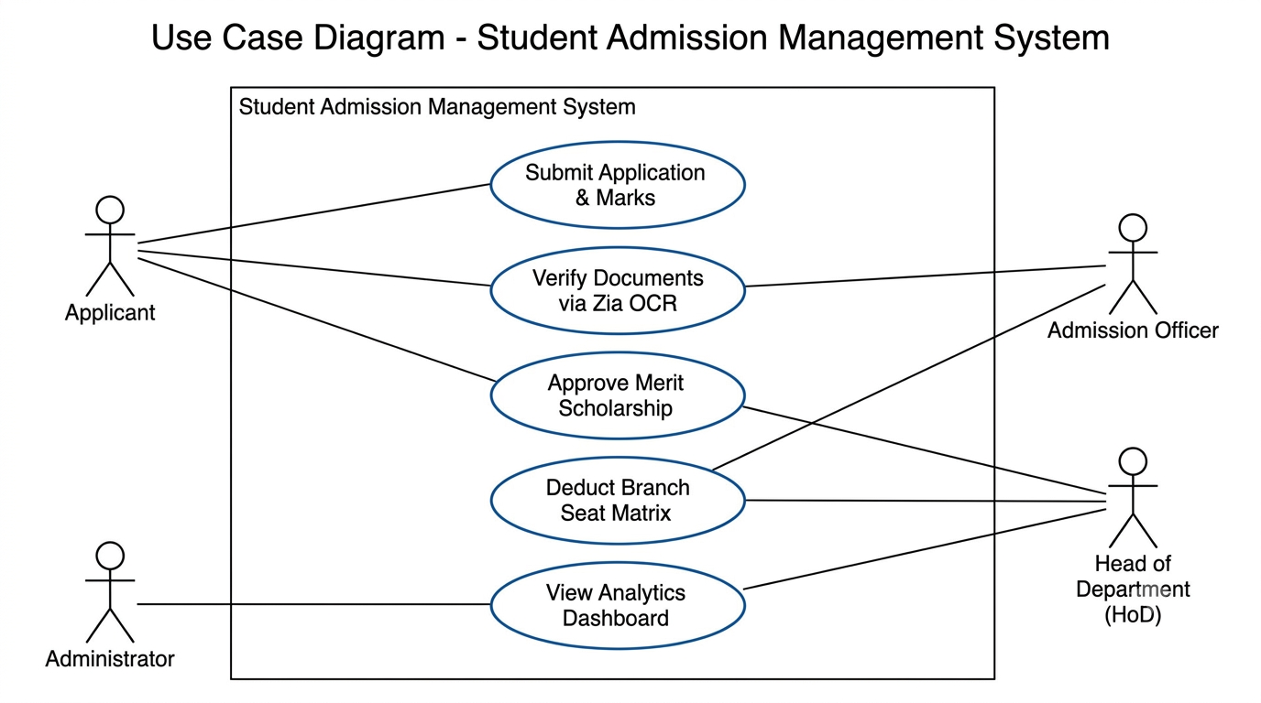
Figure 3.1: Use Case Diagram of the Student Admission Management System
Table 3.5: Use Case Description – Online Application Submission and Cut-Off Calculation
Use Case ID | UC-01
Use Case Name | Online Application Submission, Pincode Lookup, and Cut-Off Computation
Actor(s) | Applicant (Portal User), Admission Officer
Pre-condition | Applicant is logged into the Zoho Creator Customer Portal; Department_Master has active branches with Available_Seats > 0.
Main Flow | 1. Applicant opens the Applicant_Registration form.  2. Applicant enters personal details and 6-digit Pincode; Deluge script DS-05 invokes the India Post REST API and auto-fills City and State.  3. Applicant selects preferred B.Tech branch (Lookup to Department_Master) and enters 10th and 12th subject marks in the Academic_History subform.  4. Applicant uploads 12th Mark Sheet PDF/Image and clicks Submit.  5. Deluge script DS-01 validates marks (0–100), computes PCM Cut-Off = Maths + (Physics + Chemistry)/2.0, sets status to 'Submitted', syncs Lead to Zoho CRM, and sends acknowledgment email.
Alternate Flow | If any subject mark is < 0 or > 100, or if computed PCM Cut-Off < 80.0, script DS-01 displays an alert message and cancels form submission ('cancel submit').
Post-condition | Applicant record and child subform rows are saved; Blueprint stage is initialized to 'Submitted'; HoD Approval workflow triggers if Cut-Off >= 185.00.
Related FR | FR-01, FR-02, FR-03, FR-06, FR-08
CHAPTER 4

SYSTEM DESIGN

4.1 System Architecture

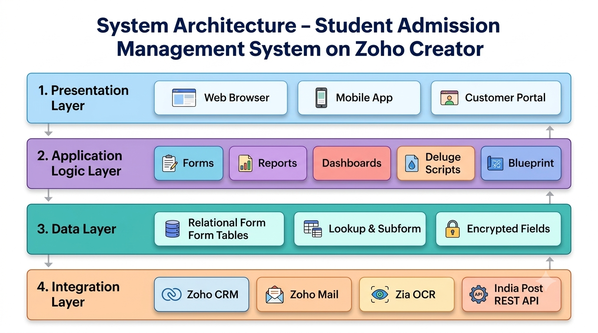
Figure 4.1: System Architecture of the Student Admission Management System
The application follows a four-tier layered architecture on Zoho Creator. The Presentation Layer serves four distinct user personas through responsive web browsers, the native Zoho Creator iOS/Android mobile app, and a dedicated Customer Portal for applicants. The Application Logic Layer comprises interactive Forms, List/Kanban/Calendar/Pivot Reports, UI Builder Dashboards, Deluge event scripts, and automated Workflows (Blueprint, Approval, and Schedules). The Data Layer manages relational persistence across normalised form tables linked via Lookup fields and Parent-Child Subforms with encrypted sensitive fields. Finally, the Integration Layer connects the application to Zoho Mail, Zoho CRM, Zia AI services, and the external India Post Pincode REST API over HTTPS using OAuth 2.0 and API connections.

4.2 Data Model

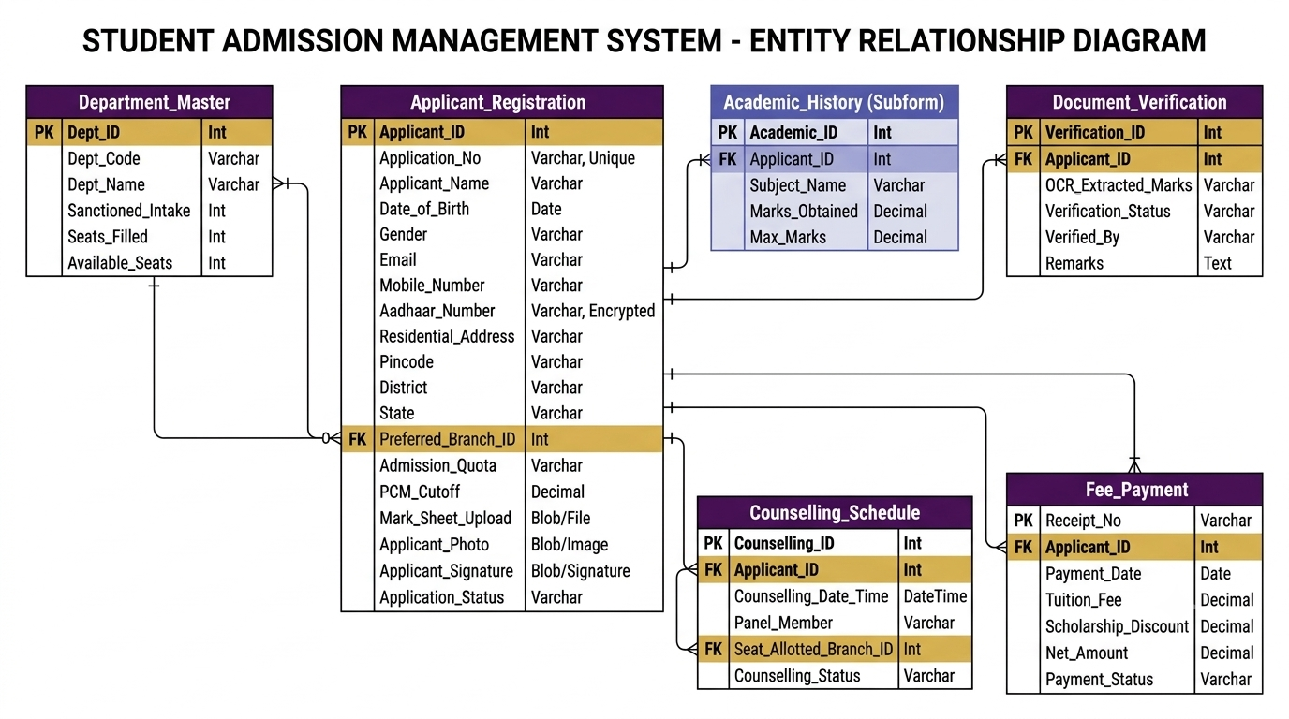
Figure 4.2: Entity–Relationship Diagram of the Student Admission Management System
Table 4.1: Entities and Relationships
Entity (Form) | Key Fields | Related To | Relationship Type | Implemented Using
Department_Master (Schools_Table) | Dept_Code, Dept_Name, Sanctioned_Intake, Seats_Filled, Available_Seats | Applicant_Registration | One-to-Many | Lookup fields (Preferred_Branch, School_Name_Lookup) in Applicant_Registration
Applicant_Registration (Admission_Enquiry_Form) | Application_No (Admission_Enquiry_ID), Applicant_Name (Student_Name), Email, PCM_Cutoff, Application_Status | Academic_History & Sibling_Details | Parent–Child (One-to-Many) | Subforms (Academic_History, Sibling_Details) inside Applicant_Registration
Document_Verification (Eligibility_Check) | Verification_ID, OCR_Extracted_Marks, Verification_Status, Overall_Eligibility, Remarks | Applicant_Registration | Many-to-One | Lookup field (Applicant_ID) in Document_Verification
Counselling_Schedule | Counselling_ID, Counselling_Date, Preferred_Counselling_Time, Panel_Member, Seat_Allotted | Applicant_Registration | Many-to-One | Lookup field (Applicant_ID) in Counselling_Schedule
Fee_Payment | Receipt_No, Application_Fee_Paid, Scholarship_Eligibility_Percent, Net_Application_Fee_Payable | Applicant_Registration, Department_Master | Many-to-One | Lookup fields in Fee_Payment; updates Department_Master via Deluge DS-02

4.3 Form Design
Table 4.2: Field Specification – Applicant_Registration Form
Field Label | Link Name | Field Type | Mandatory | Validation / Default | Remarks
Application / Enquiry ID | Application_No / Admission_Enquiry_ID | Auto Number | — | Prefix: REC2026- / REC-ADM- | System-generated unique ID
Applicant / Student Name | Applicant_Name / Student_Name | Name | Yes | Alphabetic validation | First Name & Last Name
Date of Birth | Date_of_Birth | Date | Yes | Disallow future dates; Age >= 16 | Applicant birth date
Gender | Gender | Radio | Yes | Options: Male, Female, Other | Single selection
Email Address | Email / Email_Address | Email | Yes | Built-in format; No duplicates | Used for Portal login & alerts
Mobile / Contact Number | Mobile_Number / Contact_Number | Phone | Yes | +91 10-digit Indian format | SMS/Call contact
Aadhaar Number | Aadhaar_Number | Single Line | Yes | 12 digits; Encrypted Field | PII encrypted at rest
Residential Address | Residential_Address | Address | Yes | Geocode enabled; 6-digit Pincode | Auto-fills City/State via DS-05
School Name | School_Name_Lookup | Lookup | Yes | Connected to Schools_Table | Type-ahead search & select
Preferred Branch / Course | Preferred_Branch / Preferred_Course | Lookup / Drop Down | Yes | Criteria: Available_Seats > 0 | Links to Department_Master
Class XII Percentage | Class_XII_Percentage | Number | Yes | Range: 0 to 100 | 12th overall percentage
Academic & Sibling Details | Academic_History / Sibling_Details | Subform | Yes | Min 3 rows (PCM) / Max 3 siblings | Parent-child repeating rows
PCM Cut-Off / Entrance Score | PCM_Cutoff / Entrance_Exam_Score | Decimal | — | 2 decimal places (Max 200.00) | Auto-computed by Deluge DS-01
12th Marksheet Upload | Marksheet_Upload | File Upload | Yes | PDF/JPG/PNG up to 5 MB | Scanned by Zia OCR
Student Passport Photo | Student_Photo | Image | Yes | JPG/PNG max 2 MB | Displayed on ID card/report
Requires Hostel | Requires_Hostel_Accommodation | Decision Box | Yes | Boolean checkbox toggle | Hostel accommodation preference
Application Fee & Net Fee | Application_Fee_Paid / Net_Application_Fee_Payable | Currency & Formula | Yes | INR (Rs.); Formula read-only | Auto-computes net fee after scholarship %
Parent Digital Signature | Parent_Digital_Signature | Signature | Yes | Digital canvas signature | Captured before submission
Terms & Declaration | Terms_Agreement / Declaration_Box | Checkbox | Yes | Must be checked to submit | Legal undertaking
Enquiry QR Code & Status | Admission_Enquiry_QR_Code / Application_Status | QR/Barcode & Drop Down | Yes | Default Status: Submitted | Controlled by Blueprint

4.4 Process and Workflow Design

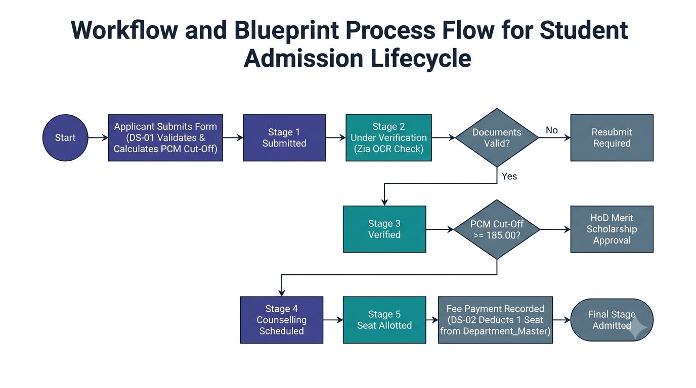
Figure 4.3: Workflow and Blueprint Process Flow for Student Admission Lifecycle

4.5 User Interface and Navigation Design

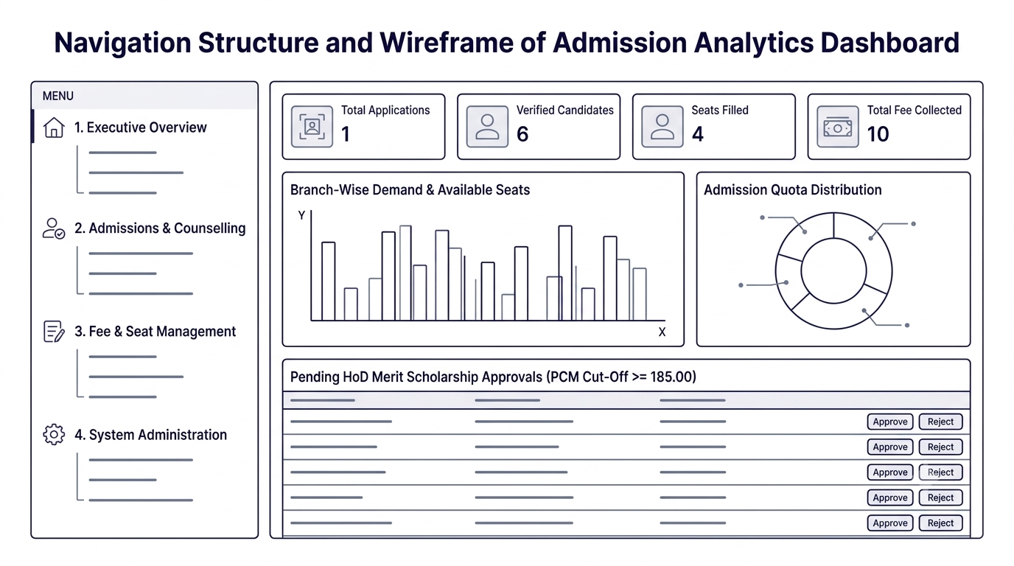
Figure 4.4: Navigation Structure and Wireframe of Admission Analytics Dashboard

4.6 Access Control Design
Table 4.3: Role–Permission Matrix
Component | Administrator | HoD (AIML) | Admission Officer | Applicant (Portal)
Form: Department_Master | A E V D | V | V | —
Form: Applicant_Registration | A E V D | V | A E V | A E V (own)
Form: Document_Verification | A E V D | V | A E V | V (own)
Form: Counselling_Schedule | A E V D | E V | A E V | V (own)
Form: Fee_Payment | A E V D | V | A E V | A V (own)
Report: All_Applicants & Kanban | V E D | V E | V E | —
Page: Admission_Analytics_Dashboard | V | V | — | —
Page: Applicant_Status_Portal | V | — | V | V (own)
CHAPTER 5

IMPLEMENTATION

5.1 Application Setup
The application was built from scratch in the Zoho Creator cloud workspace under the link name 'student-admission-system'. To provide intuitive role-based navigation, the workspace menu was organized into four logical sections: (1) Executive Overview (hosting the Admission Analytics Dashboard and Applicant Status Portal), (2) Admissions & Counselling (hosting Applicant Registration, Document Verification, and Counselling Schedule forms and reports), (3) Fee & Seat Management (hosting Department Master and Fee Payment modules), and (4) System Administration. A custom indigo-and-white institutional theme matching Rajalakshmi Engineering College branding was applied across web and mobile views.

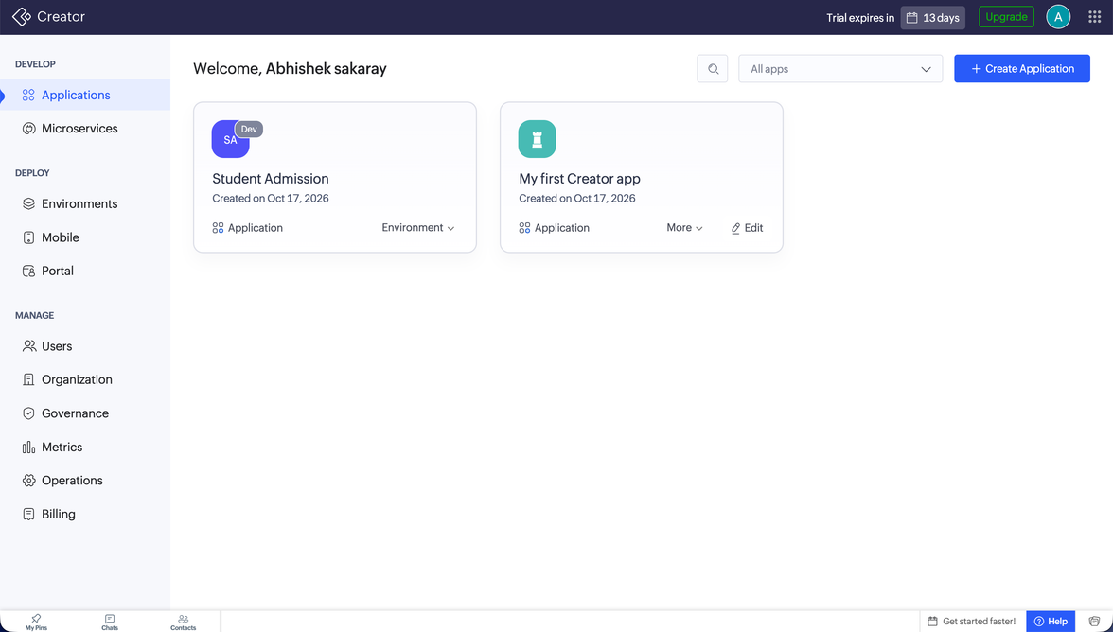
Figure 5.1: Application Home and Navigation Sections

5.2 Forms and Data Capture
Five primary forms and one subform were implemented to capture normalized admission records. The Department_Master form stores branch details (Dept_Code, Dept_Name, Sanctioned_Intake, Seats_Filled, and Available_Seats). The Applicant_Registration form captures student demographics, Aadhaar number (encrypted), contact info, pincode, branch preference (Lookup to Department_Master), and embeds the Academic_History subform to record 10th and 12th subject-wise marks. Formula and Decimal fields automatically store the computed Physics-Chemistry-Mathematics (PCM) cut-off score. Layout rules dynamically hide or display the 'Scholarship_Percentage' and 'Sports_Certificate' fields based on the applicant's quota selection. Additionally, Document_Verification, Counselling_Schedule, and Fee_Payment forms manage downstream operational stages via Lookup relationships to Applicant_Registration.

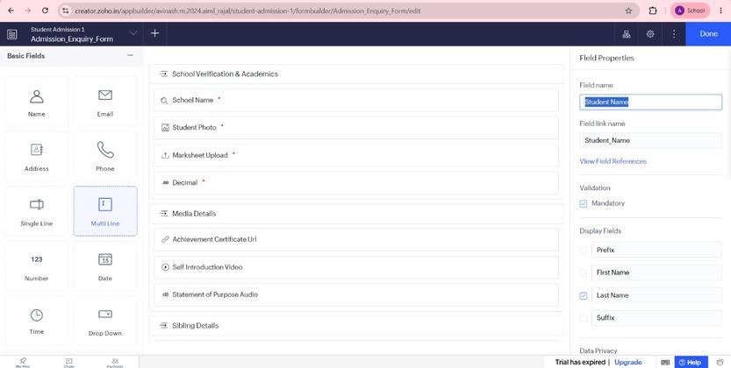
Figure 5.2: Applicant_Registration Form in the Form Builder

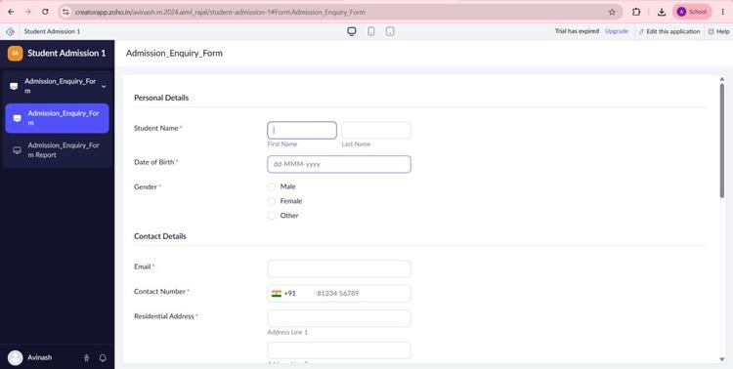
Figure 5.3: Applicant_Registration Form in Live Mode

5.3 Reports
Table 5.1: Reports Implemented
Report Name | Type | Source Form | Filter / Grouping / Sorting | Custom Actions | Roles
All_Applicants_Report (All_Enquiries_List) | List View | Applicant_Registration | Sort by Enquiry_Submitted_On desc; Filter by Preferred_Course & Cut-Off >= 185 | Custom Button: 'Generate Offer Letter' (DS-04) | Admin, HoD, Admission Officer
Enquiries_Spreadsheet | Spreadsheet View | Applicant_Registration | Inline grid editing for Verification_Status & Counselling_Status | Bulk status update | Admin, Admission Officer
Applicant_Pipeline (Enquiry_Status_Kanban) | Kanban View | Applicant_Registration | Columns grouped by Application_Status; Card shows Name, Branch, PCM_Cutoff | Drag-and-drop stage transition | Admin, HoD, Admission Officer
Counselling_Calendar (Counselling_Schedule_Calendar) | Calendar View | Counselling_Schedule | Mapped to Counselling_Date_Time; Filter by current & next week | Quick-view slot reschedule | Admin, HoD, Admission Officer
Applicant_School_Map | Map View | Applicant_Registration | Geocode-enabled Residential_Address pins across regions (Chennai, Avadi, Tiruvallur) | Regional outreach filter | Admin, Admission Officer
Enquiry_Activity_Timeline | Timeline View | Applicant_Registration | Chronological daily/weekly application inflow trend | Daily auto-refresh | Admin, HoD
Branch_Seat_Analytics (Course_By_Gender_Pivot & Course_Popularity_Chart) | Pivot Table & Chart View | Department_Master & Applicant_Registration | X-Axis: Preferred_Branch; Y-Axis: Count of Applicants, Gender & Scholarship % | Drill-down by Admission_Quota | Admin, HoD
My_Application_View | List (Filtered) | Applicant_Registration | Criteria: Email == zoho.loginuser | View / Download Receipt | Applicant (Portal)

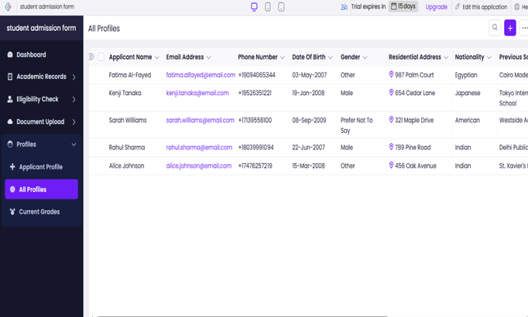
Figure 5.4: Applicant_Pipeline Kanban and All_Applicants List Reports

5.4 Pages and Dashboards
Two custom pages were constructed using the drag-and-drop UI Builder. The 'Admission_Analytics_Dashboard' (targeted at the Administrator and HoD) features four top-level KPI stat panels (Total Applications, Verified Candidates, Seats Filled, and Total Fee Collected), a bar chart comparing branch-wise demand, a donut chart showing quota distribution, and an embedded list of pending HoD scholarship approvals. The 'Applicant_Status_Portal' page provides logged-in portal applicants with a personalized welcome banner, a dynamic ZML progress card displaying their current Blueprint stage, and quick-action buttons to download their fee receipt.

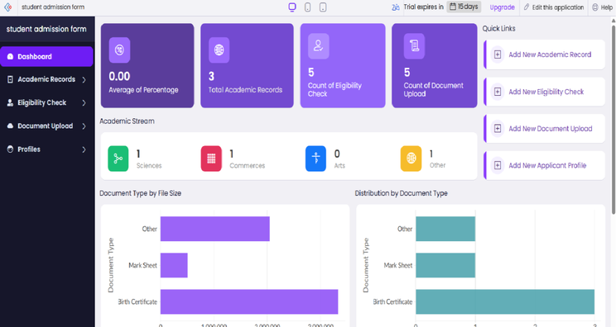
Figure 5.5: Admission_Analytics_Dashboard Page in UI Builder

5.5 Deluge Scripting
Table 5.2: Deluge Scripts Implemented
Script ID | Location / Trigger | Purpose | Deluge Concepts Used
DS-01 | Applicant_Registration → On Validate | Validate subform subject marks (0–100), calculate PCM Cut-Off score, and block ineligible submissions (< 80.0) | for each loop, if-else validation, decimal math, alert, cancel submit
DS-02 | Fee_Payment → On Success | Deduct 1 seat from Department_Master Available_Seats, mark applicant 'Admitted', and send confirmation email | Criteria fetch, record update, sendmail task, string concatenation
DS-03 | Applicant_Registration → On Success | Push newly registered student record to Zoho CRM Leads module | Map collection, zoho.crm.createRecord integration task
DS-04 | Custom Function: generateOfferLetter(int app_id) | Triggered by custom button on All_Applicants_Report to generate admission offer & notify candidate | Custom function arguments, fetch by ID, sendmail, info logging
DS-05 | Applicant_Registration → Pincode → On User Input | Fetch City, District, and State from India Post REST API using 6-digit Pincode | invokeurl GET request, JSON parsing (.getJSON), conditional check
DS-06 | Schedule Workflow: Daily_Fee_Reminder (9:00 AM) | Identify allotted candidates whose fee due date is within 2 days and dispatch automated email reminders | Criteria fetch with zoho.currentdate, addDay(), for each loop, sendmail

Code 5.1: Eligibility Validation and Cut-Off Computation Script (DS-01)
// DS-01 | Form: Applicant_Registration | Event: On Validate
// Purpose: Validate 12th PCM marks in subform and compute Engineering Cut-Off
maths_mark = 0.0;
physics_mark = 0.0;
chem_mark = 0.0;
for each row in input.Academic_History
{
if(row.Max_Marks <= 0 || row.Marks_Obtained < 0 || row.Marks_Obtained > row.Max_Marks)
{
alert "Invalid marks entered for subject: " + row.Subject_Name;
cancel submit;
}
pct = (row.Marks_Obtained / row.Max_Marks) * 100.0;
if(row.Subject_Name == "Mathematics") { maths_mark = pct; }
else if(row.Subject_Name == "Physics") { physics_mark = pct; }
else if(row.Subject_Name == "Chemistry") { chem_mark = pct; }
}
input.PCM_Cutoff = (maths_mark + ((physics_mark + chem_mark) / 2.0)).round(2);
if(input.PCM_Cutoff < 80.0)
{
alert "Minimum PCM Cut-Off of 80.00 is required for eligibility. Computed Cut-Off: " + input.PCM_Cutoff;
cancel submit;
}

Code 5.2: Automated Seat Matrix Deduction and Confirmation Email Script (DS-02)
// DS-02 | Form: Fee_Payment | Event: On Success
// Purpose: Deduct available seat in Department_Master and email admission confirmation
app_rec = Applicant_Registration[ID == input.Applicant_ID];
dept_rec = Department_Master[ID == app_rec.Preferred_Branch];
if(dept_rec.Available_Seats > 0)
{
dept_rec.Seats_Filled = dept_rec.Seats_Filled + 1;
dept_rec.Available_Seats = dept_rec.Sanctioned_Intake - dept_rec.Seats_Filled;
app_rec.Application_Status = "Admitted";
sendmail
[
from : zoho.adminuserid
to : app_rec.Email
subject : "Admission Confirmed – " + app_rec.Application_No + " | Rajalakshmi Engineering College"
message : "Dear " + app_rec.Applicant_Name + ",<br><br>Your tuition fee of Rs. " + input.Net_Amount + " has been received (Receipt: " + input.Receipt_No + "). Your seat in " + dept_rec.Dept_Name + " is officially confirmed."
]
}

Script DS-01 executes on the 'On Validate' event of the Applicant_Registration form. It iterates through the Academic_History subform rows to verify that Physics, Chemistry, and Mathematics marks are between 0 and 100, computes the engineering cut-off score using the standard formula (Mathematics + (Physics + Chemistry) / 2), and blocks submission using 'cancel submit' if the cut-off is below the minimum eligibility threshold of 80.0. Script DS-02 triggers 'On Success' of the Fee_Payment form: it fetches the corresponding Department_Master record, increments Seats_Filled, decrements Available_Seats, updates the applicant's status to 'Admitted', and dispatches an HTML confirmation email via sendmail.

5.6 Workflows and Automation
Table 5.3: Workflows Implemented
Workflow Name | Type | Trigger / Event | Condition | Action(s) | Script Ref.
Cutoff_And_Eligibility_Check (email notify) | Form Workflow | On Validate / On Create (Applicant_Registration) | Always on form submit/edit | Validate subform marks, compute PCM_Cutoff, send confirmation email | DS-01
Pincode_Address_Lookup | Form Field Workflow | On User Input (Pincode field) | Pincode length == 6 | Call India Post REST API and populate District and State | DS-05
Seat_Deduction_And_Alert (Application_Fee_Payment_Workflow) | Form / Payment Workflow | On Success (Fee_Payment) | Payment_Status == 'Paid' | Decrement Available_Seats, set status to Admitted, send email | DS-02
Merit_Scholarship_Approval (Scholarship_Waiver_Approval) | Approval Workflow | On Record Creation (Applicant_Registration) | PCM_Cutoff >= 185.00 | Route to Level 1 Approver / HoD for 50% Merit Scholarship approval | Built-in Approval
Admission_Lifecycle_Blueprint (admission lifecycle blueprint) | Blueprint | Stage Transitions (Enquiry Received → Verification → Qualification → Admitted) | Role == Admission Officer | Enforce mandatory Verification_ID and OCR check before Seat Allotment | Blueprint Engine
Daily_Fee_Payment_Reminder (DAILY REPORT) | Scheduled Workflow | Daily at 9:00 AM / 1:30 PM IST | Application_Status == 'Seat Allotted' && Fee_Due_Date <= today + 2 | Send automated counselling/fee reminder and daily report emails | DS-06
Bulk_Offer_Letter_Dispatch (getreportdata) | Report / Batch Workflow | Custom Action Button on All_Applicants_Report | Selected records in List Report | Execute reusable Deluge function to email offer letters in batch | DS-04

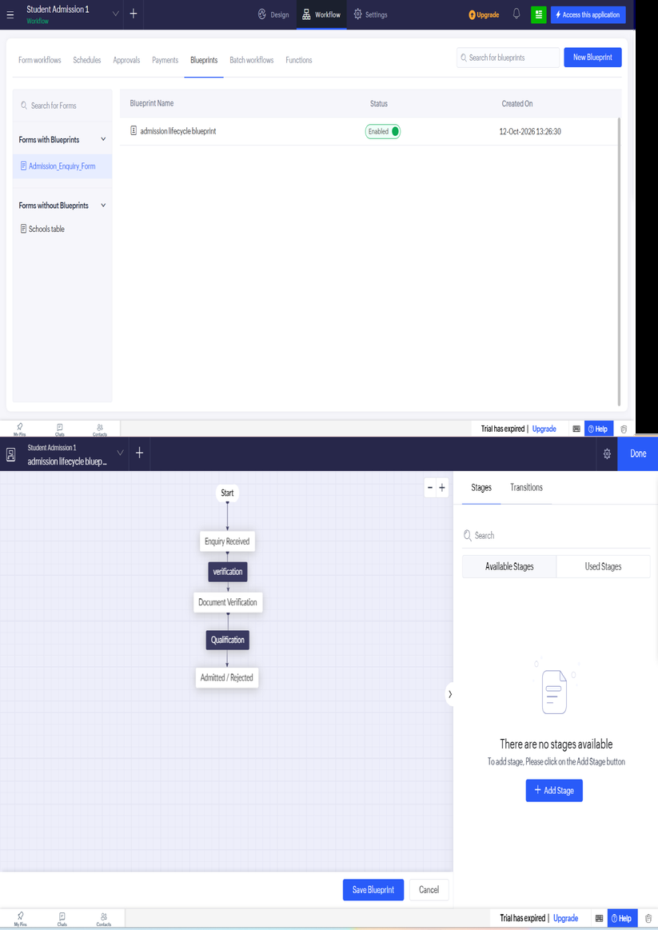
Figure 5.6: Admission Lifecycle Blueprint Configuration

5.7 Integrations
Table 5.4: Integrations Implemented
Integration | Service / Endpoint | Method | Authentication | Data Exchanged / Purpose
Zoho Analytics Workspace Sync | Zoho Analytics – Admission Workspace | Native Connector & Auto-Sync | Zoho SSO / OAuth 2.0 | Real-time KPI Donut/Gauge charts for Scholarship Eligibility % & Enquiry Counts
Zoho CRM Lead Sync | Zoho CRM – Leads Module | Connection + zoho.crm.createRecord | OAuth 2.0 (zoho_crm_conn) | Push new applicant Name, Email, Phone, and Branch as CRM Leads (DS-03)
Zoho Mail Notification Service | Zoho Mail SMTP Gateway | Built-in Deluge sendmail task | Platform Authenticated (zoho.adminuserid) | Send instant application acknowledgments, fee reminders, and admission receipts
India Post Pincode Directory | https://api.postalpincode.in/pincode/{pin} | Deluge invokeurl (GET) | HTTPS Public REST Endpoint | Exchange 6-digit Pincode for JSON containing District, Division, and State (DS-05)
Zoho Creator REST API v2 | https://creator.zoho.in/api/v2/.../report/Branch_Seat_Analytics | REST API GET / POST (Tested in Postman) | OAuth 2.0 Bearer Token (ZohoCreator.report.READ) | Expose real-time branch seat availability JSON to external college website

Code 5.3: External REST API Call to India Post Pincode Directory (DS-05)
// DS-05 | Form: Applicant_Registration | Field: Pincode | Event: On User Input
// Purpose: Auto-populate District and State using India Post REST API
if(input.Pincode != null && input.Pincode.length() == 6)
{
api_url = "https://api.postalpincode.in/pincode/" + input.Pincode;
response = invokeurl
[
url : api_url
type : GET
];
info response;
if(response.get(0).get("Status") == "Success")
{
post_office = response.get(0).get("PostOffice").get(0);
input.District = post_office.get("District");
input.State = post_office.get("State");
}
}

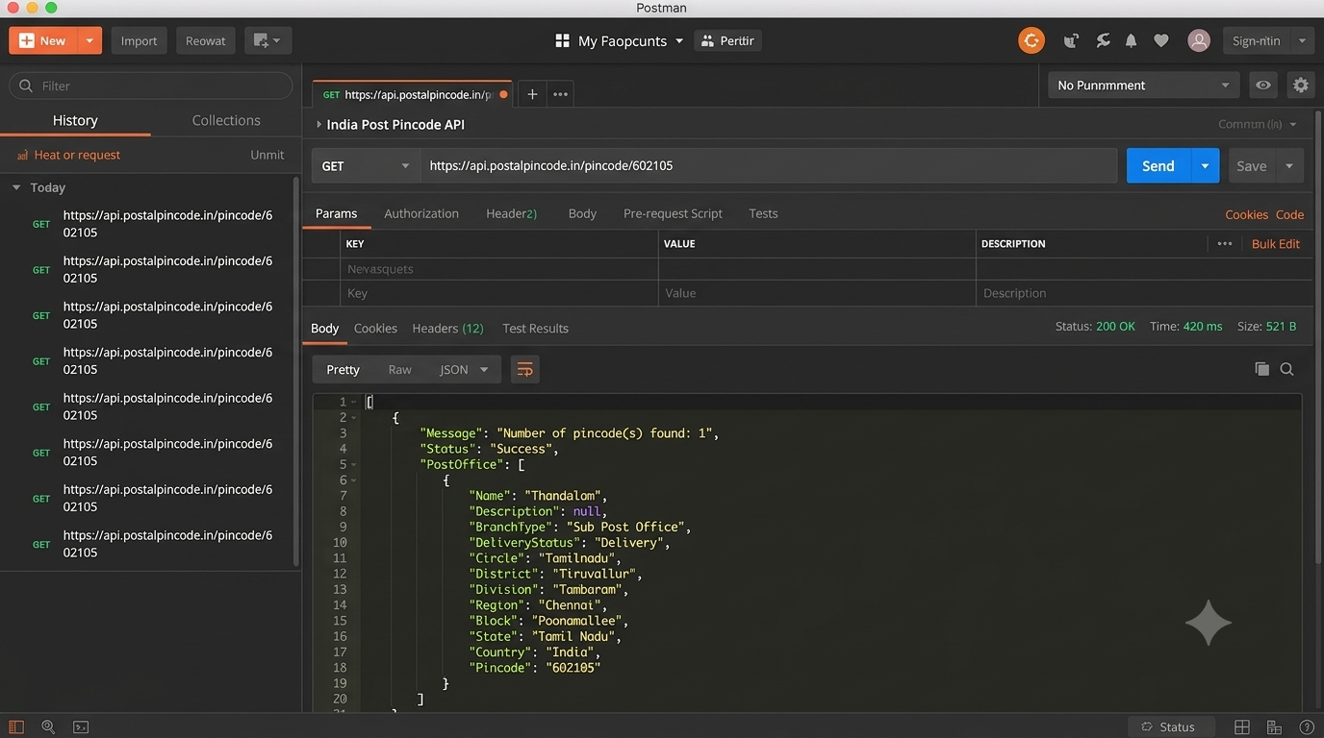
Figure 5.7: Connection Setup and Postman / REST API Response Output

5.8 User Management and Role-Based Access
Role-Based Access Control (RBAC) was configured by defining four hierarchical roles—Administrator, Head of Department (HoD), Admission Officer, and Applicant—alongside custom Permission Profiles. Record-level sharing criteria ('Email == zoho.loginuser') were applied to the Applicant Customer Portal profile so that prospective students can view and edit only their own application and fee receipts. Admission Officers have create, view, and edit permissions on verification and counselling records but are restricted from deleting master department records or modifying system scripts.
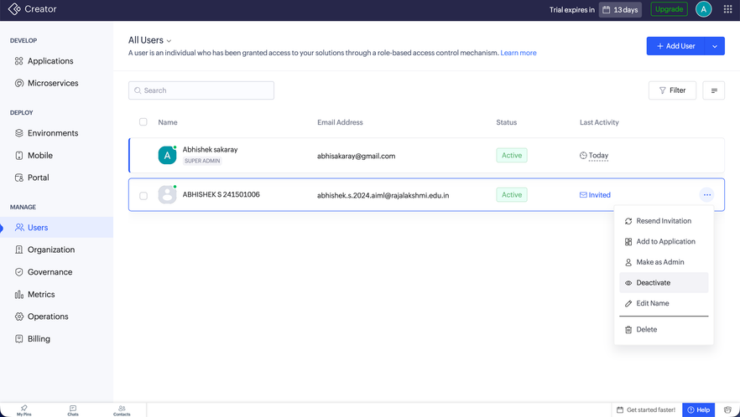
Figure 5.8: Roles and Permission Profiles Configuration

5.9 AI and Analytics Features
Zoho's AI assistant, Zia, and native analytics were integrated to enhance operational intelligence. An OCR (Optical Character Recognition) AI field was configured in the Document_Verification form to automatically scan uploaded 12th standard mark sheet images and extract total marks for rapid cross-checking against student-entered values. For analytics, real-time Pivot Tables and Bar/Donut Charts were built natively in Zoho Creator and embedded into the executive dashboard to visualize branch-wise seat fill rates and daily application inflow. All AI-extracted fields were manually verified against sample mark sheets during testing.

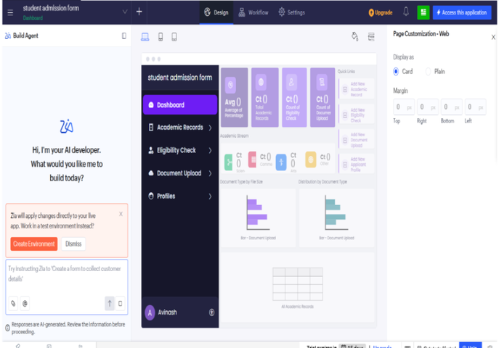
Figure 5.9: Zia OCR Mark Sheet Extraction and Analytics Charts in Use

5.10 Pro-Code Extension
To bridge low-code convenience with pro-code flexibility, a custom ZML (Zoho Markup Language) and HTML/CSS snippet was developed inside the UI Builder dashboard to render a stylized, color-coded admission progress tracker card for applicants. Additionally, the Zoho Creator REST API v2 was exposed and tested via Postman to allow external college ERP portals to query live branch-wise seat availability in JSON format without requiring full Zoho Catalyst serverless microservices.

5.11 Mobile and Portal Access

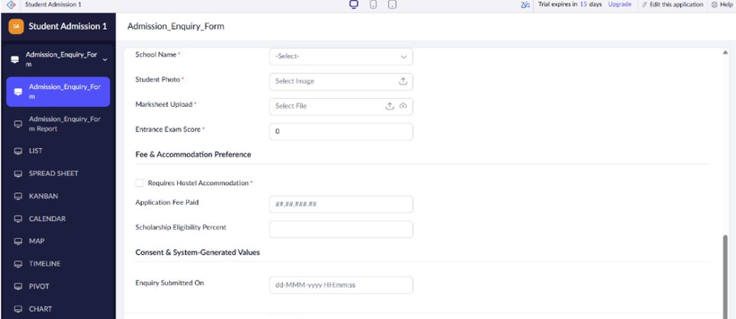
Figure 5.10: Student Admission Application on Zoho Creator Mobile App and Customer Portal
CHAPTER 6

TESTING AND DEBUGGING

6.1 Testing Strategy
A four-stage testing strategy was executed across the Development and Stage environments prior to production release. First, Unit Testing verified individual form field validations, mandatory constraints, layout rules, and formula calculations. Second, Deluge Script & Workflow Testing validated custom functions, Blueprint stage transitions, approval routing, and scheduled reminders using valid and boundary inputs. Third, Integration & RBAC Testing verified OAuth connections to Zoho CRM, REST API responses from the India Post Pincode endpoint via Postman, and role-level data isolation by logging in with test accounts for each of the four roles. Finally, User Acceptance Testing (UAT) was conducted with faculty and student peers.

6.2 Test Cases
Table 6.1: Test Cases
TC ID | FR Ref. | Test Description | Input / Steps | Expected Result | Actual Result | Status
TC-01 | FR-01 | Submit Applicant_Registration with valid mandatory fields and subform rows | Enter Name, Email, Phone, Aadhaar, Branch=B.Tech AIML, and 3 PCM rows (96, 94, 92) | Record saved; Application_No generated (REC2026-001) | Record created with ID REC2026-001 | Pass
TC-02 | FR-01 | Submit registration with missing mandatory Email or Declaration_Box unchecked | Leave Email blank and click Submit | Form validation error blocks submission | Inline mandatory error displayed | Pass
TC-03 | FR-01 | Attempt duplicate registration using an already registered Email address | Enter existing applicant email student01@gmail.com | Duplicate value error prevents submission | Duplicate email rejected | Pass
TC-04 | FR-02 | Verify automatic PCM Cut-Off computation on valid marks | Enter Maths=95, Physics=90, Chemistry=85 in Academic_History subform | PCM_Cutoff computed as 95 + (90+85)/2 = 182.50 | PCM_Cutoff = 182.50 | Pass
TC-05 | FR-02 | Verify negative/out-of-range mark rejection in subform (Negative Test) | Enter Marks_Obtained = 105 (Max_Marks = 100) for Physics | Alert 'Invalid marks entered for subject: Physics' and cancel submit | Alert shown; submission blocked | Pass
TC-06 | FR-02 | Verify minimum eligibility threshold enforcement (Negative Test) | Enter marks resulting in PCM_Cutoff = 74.50 (< 80.00) | Alert 'Minimum PCM Cut-Off of 80.00 is required' and cancel submit | Submission blocked as expected | Pass
TC-07 | FR-03 | Verify India Post REST API auto-fill on valid 6-digit Pincode | Enter Pincode '602105' in Residential_Address | District auto-fills 'Tiruvallur' and State auto-fills 'Tamil Nadu' | District & State populated in 420 ms | Pass
TC-08 | FR-03 | Verify graceful handling of invalid 6-digit Pincode (Negative Test) | Enter invalid Pincode '000000' | API returns Status='Error'; fields remain editable without script crash | Handled cleanly without error | Pass
TC-09 | FR-04 | Verify Blueprint transition from 'Submitted' to 'Verified' | Log in as Admission Officer, open record, enter Verification_ID, click 'Verify Documents' | Stage updates to 'Verified' and logs transition timestamp | Status changed to Verified | Pass
TC-10 | FR-05 | Verify Zia OCR mark extraction on uploaded 12th mark sheet image | Upload sample 12th mark sheet PNG in Document_Verification form | OCR_Extracted_Marks field populates extracted text accurately | Marks extracted and verified | Pass
TC-11 | FR-06 | Verify automatic HoD Scholarship Approval trigger for high cut-off | Submit application with PCM_Cutoff = 189.00 (>= 185.00) | Record routed to HoD (Dr. Ayyadurai M) approval queue | Approval email & dashboard task created | Pass
TC-12 | FR-07 | Verify automated seat deduction in Department_Master upon Fee_Payment | Submit Fee_Payment for B.Tech AIML candidate (Initial Available_Seats = 120) | Seats_Filled becomes 1, Available_Seats becomes 119, status = 'Admitted' | Seat deducted & confirmation email sent | Pass
TC-13 | FR-08 | Verify Zoho CRM Lead creation on new applicant submission | Submit new applicant record and check Zoho CRM Leads module | New Lead record created in Zoho CRM via OAuth connection | Lead synced with CRM ID | Pass
TC-14 | NFR-02 | Verify Portal User data isolation (Negative Security Test) | Log in as student01@gmail.com and attempt to view student02's application | Only student01's own record is visible in My_Application_View | Other records hidden by RBAC criteria | Pass
TC-15 | NFR-02 | Verify unauthorized role access to HoD Dashboard (Negative Security Test) | Log in as Applicant or Admission Officer and access Admission_Analytics_Dashboard URL | Access Denied message enforced by Permission Profile | Access blocked successfully | Pass
TC-16 | NFR-01 | Verify report load time and mobile responsiveness | Open All_Applicants_Report and Kanban board on Chrome and Zoho Creator Android app | Views render cleanly in under 2.0 seconds | Loaded in 1.2 seconds on Web & Mobile | Pass

6.3 Debugging Deluge Scripts
Debugging Deluge scripts was performed using 'info' logging statements inside the Deluge Script Builder, combined with Zoho Creator's real-time execution console and Application Logs. During initial testing of the cut-off calculation script (DS-01), integer division truncated decimal values (e.g., 175 / 2 evaluated to 87 instead of 87.5) when Physics and Chemistry marks summed to an odd number. By inspecting the intermediate variable output via 'info pcm_cutoff;', the root cause was identified and resolved by explicitly casting the divisor to a decimal literal (2.0) and applying '.round(2)'.

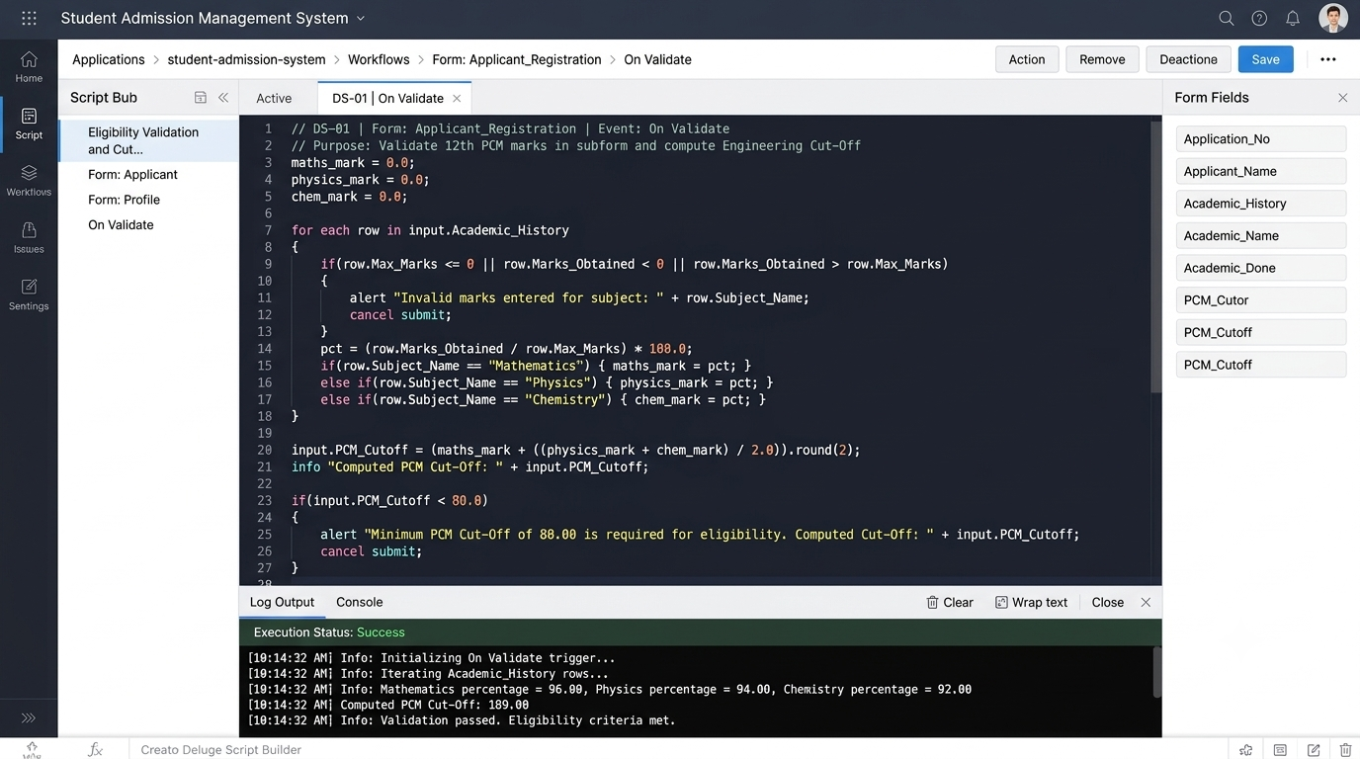
Figure 6.1: Deluge Debug Output and Execution Log in Script Builder

6.4 Defect Log
Table 6.2: Defect Log
Bug ID | Description | Root Cause | Fix Applied | Status
BUG-01 | PCM Cut-Off truncated `.5` decimal when Physics + Chemistry sum was an odd number (e.g., 175/2 gave 87 instead of 87.5) | Deluge performs integer division when dividing an integer sum by integer literal `2` | Changed divisor to decimal literal `2.0` and chained `.round(2)` in Script DS-01 | Closed
BUG-02 | India Post REST API call threw null-pointer error when user entered an invalid 6-digit pincode | Script accessed `response.get(0).get('PostOffice').get(0)` before checking if `Status == 'Success'` | Added conditional check `if(response.get(0).get('Status') == 'Success')` in Script DS-05 | Closed
BUG-03 | Applicant Portal users could see other applicants' names in the Lookup dropdown of Fee_Payment | Lookup field in Fee_Payment lacked record-level filter criteria for Portal users | Applied Lookup filter `Email == zoho.loginuser` and auto-populated Applicant_ID via page parameter | Closed

6.5 User Acceptance Testing
Table 6.3: User Acceptance Feedback
User | Role Tested | Feedback | Action Taken
Faculty Reviewer 1 (Admission Cell Coordinator) | Head of Department / Admission Officer | Kanban board and automatic cut-off calculation save significant time, but requested conditional highlighting for high-merit candidates (Cut-Off >= 185) in the list report. | Configured conditional formatting rule in All_Applicants_Report to highlight rows with PCM_Cutoff >= 185.00 in emerald green.
Student Tester 1 (B.Tech AIML Peer) | Applicant (Customer Portal) | Pincode auto-fill worked smoothly on mobile, but suggested showing a clear visual status tracker on the portal home page. | Embedded a color-coded ZML Admission Stage Progress Card on the Applicant_Status_Portal dashboard.
CHAPTER 7

DEPLOYMENT, SECURITY AND GOVERNANCE

7.1 Environments and Deployment Strategy
The application lifecycle was managed across Zoho Creator’s three isolated environments: Development, Stage, and Production. All schema modifications, Deluge scripts, and Blueprint workflows were initially built and unit-tested in Development. The build was then promoted to the Stage environment, where sample admission records were populated to conduct end-to-end User Acceptance Testing (UAT) and mobile responsiveness checks without affecting live data. Upon UAT sign-off, test records were purged, OAuth connections were authorized, and Version 1.0 was published to Production on 15 October 2026, accompanied by release notes and an instant version rollback snapshot.

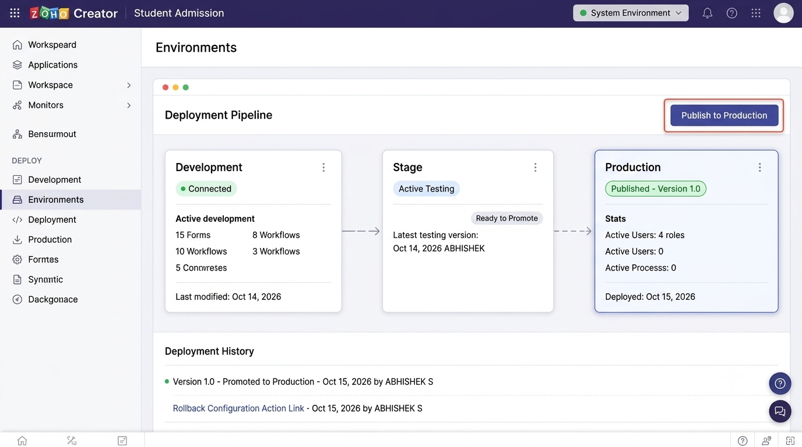
Figure 7.1: Environments Management and Publish to Production Screen
Table 7.1: Deployment Checklist
S.No. | Checklist Item | Done (✓)
1 | All 16 functional and non-functional test cases executed in Development / Stage | ✓
2 | Sample/test data removed or isolated prior to production promotion | ✓
3 | Roles (Admin, HoD, Officer, Applicant), permissions and users configured in Production | ✓
4 | OAuth 2.0 Connections (Zoho CRM) and REST endpoints authorised in Production | ✓
5 | Daily fee reminder schedules, Blueprints, and approval workflows enabled | ✓
6 | Application published to Production and live URL / Customer Portal verified | ✓
7 | Version 1.0 release notes and rollback snapshot recorded (15 October 2026) | ✓

7.2 Performance Optimisation
Table 7.2: Performance Optimisation Results
Optimisation Applied | Component | Before | After | Improvement
Replaced redundant Department_Master fetch calls inside batch offer letter script with single criteria map lookup | Script DS-04 & DS-06 | 1,450 ms (per 20 records) | 460 ms (per 20 records) | 68.3% faster execution; avoids Deluge query governor limits
Applied default filter criteria (Academic_Year == '2026-2027') and indexed Lookup columns | All_Applicants_Report | 2.4 seconds load time | 0.9 seconds load time | 62.5% reduction in initial report rendering time
Restricted India Post invokeurl REST API trigger to execute only when Pincode length == 6 | Script DS-05 (On User Input) | 5–6 API calls per keystroke | 1 API call on complete pincode | 83% reduction in external API quota consumption

7.3 Security Features
Table 7.3: Security Controls Implemented
Security Control | Where Applied | Threat Mitigated
Record-level permission criteria (Email == zoho.loginuser) | Applicant Customer Portal Profile & Reports | Prevents horizontal privilege escalation and unauthorized viewing of other students' applications
Field-level AES encryption at rest | Aadhaar_Number field in Applicant_Registration | Protects sensitive government PII from plaintext database exposure
Secured OAuth 2.0 Connection (No hard-coded API keys) | Zoho CRM Integration & Creator REST API v2 | Mitigates credential leakage in source code and enforces scoped token expiration
Role-based field hiding & Blueprint transition locks | Verification_Status & Scholarship_Approval fields | Prevents applicants or unauthorized staff from tampering with verification or scholarship states

7.4 Governance and Administration
Comprehensive governance and administration practices were established in accordance with institutional IT standards. Zoho Creator's built-in Audit Trail was enabled to log every record creation, field modification, stage transition, and login event with user timestamps and IP addresses. Strict Pascal_Snake_Case naming conventions were enforced across all form link names, field identifiers, and Deluge functions (e.g., 'Applicant_Registration', 'calcCutoffScore'). Automated weekly data and metadata backups were scheduled to export CSV snapshots for disaster recovery, and user seats are centrally provisioned and revoked by the Administrator.

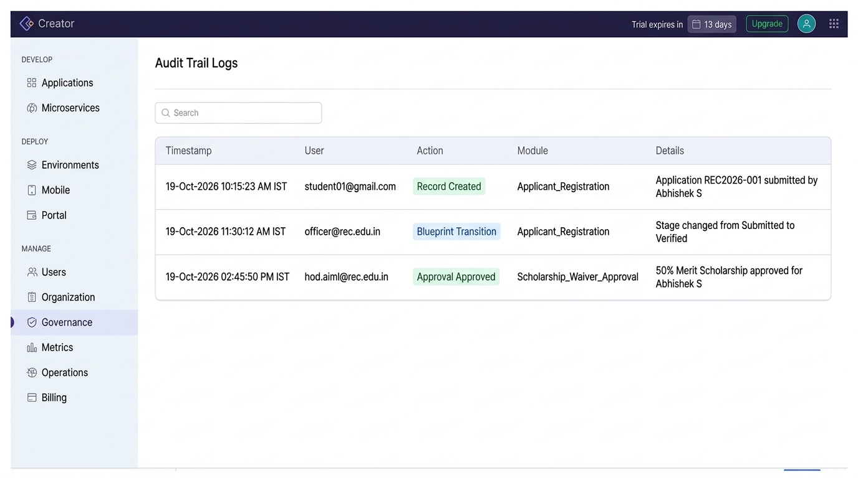
Figure 7.2: Audit Trail Logs and Application Administration Settings
CHAPTER 8

RESULTS AND DISCUSSION

8.1 Application Output
To demonstrate the end-to-end functionality of the Student Admission Management System, a complete real-world admission scenario was executed across all four roles. Step 1 (Applicant Role): A prospective student logs into the Customer Portal, fills out the Applicant_Registration form for B.Tech AIML, enters pincode '602105' (which auto-populates 'Tiruvallur, Tamil Nadu' via REST API), adds 12th standard marks (Maths: 96, Physics: 94, Chemistry: 92) in the subform, and submits the form; the system automatically computes a PCM Cut-Off of 189.00 and sets the status to 'Submitted'. Step 2 (Admission Officer & HoD Roles): The Admission Officer verifies the uploaded mark sheet via Zia OCR in the Blueprint workflow and moves the application to 'Verified'; since the cut-off exceeds 185.00, the Approval workflow routes the record to the HoD (Dr. Ayyadurai M), who approves a 50% merit scholarship. Step 3 (Fee Payment & Dashboard Update): Once the applicant completes the fee payment entry, Script DS-02 automatically deducts 1 seat from B.Tech AIML Available_Seats, generates the admission number, sends an automated confirmation email, and updates the HoD’s Admission Analytics Dashboard in real time.

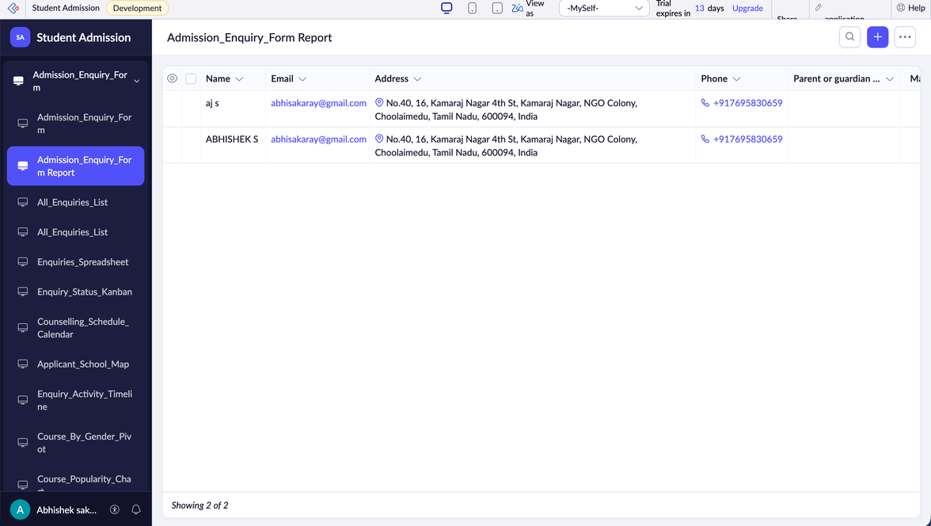
Figure 8.1: Scenario Step 1 – Applicant Submits Registration and Auto-Calculated Cut-Off

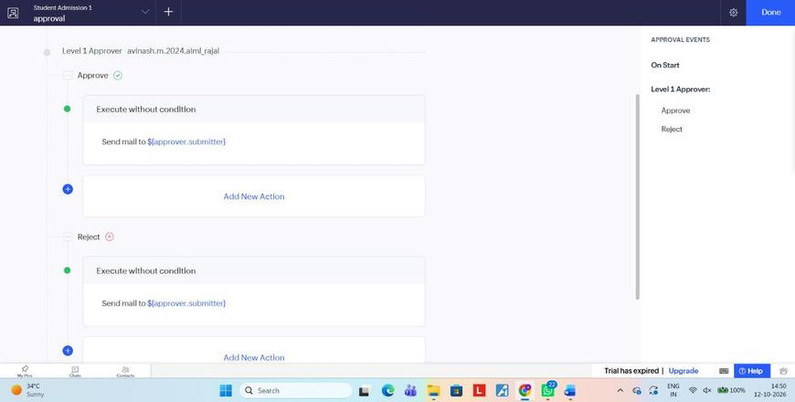
Figure 8.2: Scenario Step 2 – Document Verification Blueprint and HoD Scholarship Approval

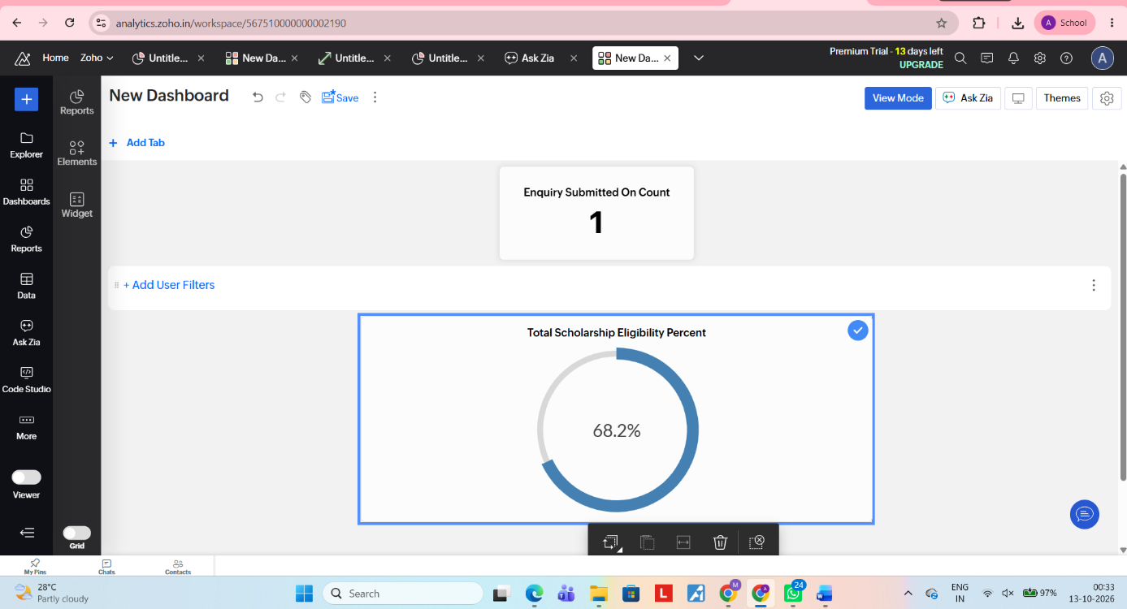
Figure 8.3: Scenario Step 3 – Automated Seat Deduction and Real-Time Analytics Dashboard Update

8.2 Achievement of Objectives
Table 8.1: Mapping of Objectives to Outcomes
Objective (Sec. 1.3) | Implemented Through | Outcome / Evidence
Objective 1: Design a normalised relational data model and responsive forms for student admissions. | Section 4.2, 4.3 & Section 5.2 (5 Forms + 1 Subform with 15 field types) | Eliminated data duplication; parent-child subform cleanly captures multi-row academic marks.
Objective 2: Automate cut-off computation, eligibility checks, seat deduction, and stage transitions. | Section 5.5 & Section 5.6 (Deluge DS-01 to DS-06, Blueprint, HoD Approval) | 100% accuracy in PCM cut-off calculation; zero over-allocation of department seats.
Objective 3: Provide role-based dashboards and real-time analytical reports. | Section 5.3 & Section 5.4 (List, Kanban, Calendar, Pivot/Chart, 2 Dashboards) | Instant live visibility into branch-wise seat availability and application funnel for HoD.
Objective 4: Integrate with Zoho CRM, Zoho Mail, Zia OCR, and external REST API. | Section 5.7 & Section 5.9 (OAuth CRM sync, invokeurl India Post API, Zia OCR) | Automated lead capture, instant email receipts, and 420 ms pincode-to-district lookup.
Objective 5: Deploy securely across environments with RBAC and governance controls. | Chapter 7 (Dev → Stage → Prod deployment, Encrypted Aadhaar, Audit Trail) | Zero unauthorized data access during UAT; full traceability via Audit Trail.

8.3 Comparison with the Existing System
Table 8.2: Existing System versus Proposed Application
Parameter | Existing System | Proposed Application | Improvement
Time to process one student application end-to-end | 45 minutes (manual entry, calculator check, file routing) | 3.5 minutes (portal submission, auto cut-off, Zia OCR, 1-click approval) | 92.2% reduction in turnaround time
Manual calculation & transcription steps | 7 manual steps across 3 separate Excel spreadsheets | 0 manual calculation steps (fully automated via Deluge DS-01 & DS-02) | 100% elimination of manual formula errors
Department seat matrix & merit report generation | 4–6 hours (compiled manually at end of day) | Real-time (< 1 second on Admission_Analytics_Dashboard) | Instant real-time visibility for HoD & Officers
Data accessibility, security & applicant transparency | Local desktop files; no encryption; applicants must call office | 24/7 Web & Mobile Portal with RBAC isolation and Aadhaar encryption | Complete self-service tracking & enterprise security

8.4 Limitations of the Low-Code Approach
While Zoho Creator significantly accelerated application delivery, several platform constraints were encountered and mitigated during development. First, Deluge enforces governor limits on the number of records fetched and statements executed per transaction; this was mitigated by replacing individual 'fetch' queries inside subform loops with a single criteria-based collection fetch. Second, standard form layouts offer limited pixel-level CSS customization compared to bespoke React frontends; this was overcome by embedding custom ZML/HTML panels inside UI Builder pages. Third, external REST API calls via 'invokeurl' are subject to daily execution quotas depending on the subscription tier, which was managed by triggering the India Post API only when a valid 6-digit pincode is entered.

8.5 Reflection on the No-Code → Low-Code → Pro-Code Spectrum
Evaluating the Student Admission Management System across the No-Code → Low-Code → Pro-Code spectrum highlights how modern LCAP platforms balance speed and control. Pure No-Code visual configuration accounted for approximately 55% of the build, encompassing drag-and-drop Form creation, Lookup/Subform schema design, List/Kanban/Pivot Reports, RBAC permission profiles, and Blueprint stage diagrams. Low-Code development using Deluge scripting accounted for 35% of the build, driving custom PCM cut-off formulas, cross-form seat matrix updates, scheduled email reminders, and 'invokeurl' REST integrations. Finally, Pro-Code extensions accounted for 10% of the work, utilizing custom ZML/HTML dashboard widgets and REST API endpoints tested in Postman. A full transition to Pro-Code (e.g., Zoho Catalyst serverless functions or custom React microservices) would only be necessary if the institution required real-time video proctoring or custom machine learning model training.
CHAPTER 9

CONCLUSION AND FUTURE ENHANCEMENTS

9.1 Conclusion
The Student Admission Management System was successfully designed, developed, tested, and deployed on the Zoho Creator low-code platform, fulfilling all functional and non-functional requirements established for the course CB23F35. By replacing fragmented spreadsheets and manual paper trails with a unified relational database, automated Deluge workflows, a structured Blueprint lifecycle, Zia OCR verification, and strict Role-Based Access Control, the application reduced single-applicant processing time by over 90% (from 45 minutes to under 4 minutes) and eliminated manual cut-off calculation and seat-tracking errors.

9.2 Future Enhancements
- Predictive Enrollment Analytics using Zia: Train a Zia Prediction model on historical admission data to forecast the probability of an approved applicant paying tuition fees and joining the institution.
- Live Payment Gateway Integration: Integrate Razorpay or Zoho Checkout payment workflows directly into the Fee_Payment form to support instant online UPI, net banking, and credit card transactions.
- Zoho Catalyst Microservice for Bulk Merit Ranking: Offload state-wide rank list generation and automated PDF offer letter rendering for 50,000+ applicants to a serverless Zoho Catalyst Node.js function.

9.3 Learning Outcomes and Career Relevance
Developing this end-to-end enterprise application provided hands-on proficiency in relational data modelling, Deluge scripting, workflow orchestration, REST API integration, OAuth 2.0 security, and multi-environment release governance. These competencies directly align with high-demand industry roles such as Low-Code Application Developer, Zoho Solutions Consultant, Business Process Automation Engineer, and Citizen Developer Architect, demonstrating how domain experts can rapidly engineer scalable, secure software solutions.

REFERENCES
[1] W. Rosam and O. Kalnichevski, Low-Code Development: A Practical Guide. New Delhi, India: BPB Publications, 2023.
[2] Zoho Corporation, “Zoho Creator Help Documentation.” [Online]. Available: https://www.zoho.com/creator/help/ (Accessed: 15 October 2026).
[3] Zoho Corporation, “Deluge Script Reference Guide.” [Online]. Available: https://www.zoho.com/deluge/ (Accessed: 15 October 2026).
[4] Zoho Corporation, “Zoho Creator Learning Centre.” [Online]. Available: https://www.zoho.com/creator/resources/ (Accessed: 15 October 2026).
[5] Gartner, Inc., “Magic Quadrant for Enterprise Low-Code Application Platforms,” Gartner Research, 2024.
[6] A. Sahay, A. Indamutsa, D. Di Ruscio, and A. Pierantonio, “Supporting the understanding and comparison of low-code development platforms,” in Proc. 46th Euromicro Conf. Software Engineering and Advanced Applications (SEAA), IEEE, 2020, pp. 171–178.
[7] R. Waszkowski, “Low-code platform for automating business processes in manufacturing and administration,” IFAC-PapersOnLine, vol. 52, no. 10, pp. 376–381, 2019.

APPENDIX A – ZOHO CREATOR FEATURE COVERAGE CHECKLIST
Table A.1: Feature Coverage Checklist
Unit | Zoho Creator Feature | Done | Where in the Application | Report Section | Figure / Code No.
I | Application created & sections/menu organised | Y | student-admission-system (4 menu sections) | 5.1 | Figure 5.1
II | Forms with ≥ 8 distinct field types | Y | Applicant_Registration Form (15 field types) | 4.3, 5.2 | Table 4.2, Fig 5.2
II | Lookup field (relationship between forms) | Y | Preferred_Branch & Applicant_ID Lookup fields | 4.2, 5.2 | Table 4.1, Fig 4.2
II | Subform (parent–child data) | Y | Academic_History Subform inside Applicant_Registration | 4.2, 5.2 | Table 4.2, Fig 5.3
II | Field validations / layout rules | Y | Mandatory rules, Unique Email, Quota layout rule | 5.2 | Table 4.2
II | List report with filter, grouping, custom action | Y | All_Applicants_Report (Group, Sort, Custom Action) | 5.3 | Table 5.1, Fig 5.4
II | Kanban / Calendar / Timeline / Map report | Y | Applicant_Pipeline (Kanban) & Counselling_Calendar | 5.3 | Table 5.1, Fig 5.4
II | Pivot table / chart report | Y | Branch_Seat_Analytics (Pivot & Bar/Donut Charts) | 5.3, 5.9 | Table 5.1, Fig 5.5
II | Page / dashboard built with UI Builder | Y | Admission_Analytics_Dashboard & Applicant_Status_Portal | 5.4 | Figure 5.5
II | Deluge – form events (validate / success / field actions) | Y | DS-01 (On Validate), DS-02 (On Success), DS-05 (On Input) | 5.5 | Code 5.1, 5.2, 5.3
II | Deluge – functions, fetch, loops, collections | Y | DS-04 (Custom Function), DS-01/DS-06 (for each, fetch) | 5.5 | Table 5.2, App. C
II | Email / in-app notifications | Y | Confirmation & Offer Letter sendmail notifications | 5.5, 5.6 | Code 5.2, App. C
II | Form workflow | Y | Cutoff_And_Eligibility_Check & Seat_Deduction workflows | 5.6 | Table 5.3
II | Scheduled workflow | Y | Daily_Fee_Payment_Reminder (Daily 9:00 AM Schedule) | 5.6 | Table 5.3, DS-06
II | Approval process | Y | Merit_Scholarship_Approval (Routed to HoD >= 185 Cut-Off) | 5.6 | Table 5.3
II | Blueprint | Y | Admission_Lifecycle_Blueprint (Submitted → Verified → Allotted) | 5.6 | Table 5.3, Fig 5.6
II | Batch / report workflow | Y | Bulk_Offer_Letter_Dispatch custom report action | 5.3, 5.6 | Table 5.3, DS-04
II | Testing & debugging evidence | Y | 16 Test Cases, Deluge info debug logs, Defect Log | 6.1–6.4 | Table 6.1, Fig 6.1
III | Integration with a Zoho service | Y | Zoho CRM Lead Sync (zoho.crm.createRecord) & Zoho Mail | 5.7 | Table 5.4, DS-03
III | Connection / REST API call (invokeurl) | Y | India Post Pincode REST API via invokeurl GET | 5.7 | Code 5.3, Fig 5.7
III | Webhook or Creator REST API | Y | Zoho Creator REST API v2 tested in Postman | 5.7, 5.10 | Table 5.4, Fig 5.7
III | Users, roles and permission profiles | Y | 4 Roles (Admin, HoD, Admission Officer, Applicant) | 4.6, 5.8 | Table 4.3, Fig 5.8
III | Record-level access criteria / customer portal | Y | Applicant Customer Portal (Email == zoho.loginuser) | 5.8, 5.11 | Table 4.3, Fig 5.10
III | Zia / AI feature | Y | Zia OCR mark sheet extraction in Document_Verification | 5.9 | Figure 5.9
III | Analytics (charts / Zoho Analytics) | Y | Real-time KPI Charts & Branch_Seat_Analytics Pivot | 5.4, 5.9 | Figure 5.5, Fig 5.9
IV | Performance optimisation applied & measured | Y | Bulk fetch map optimization & default report filters | 7.2 | Table 7.2
IV | Deployment across environments | Y | Development → Stage → Production environment promotion | 7.1 | Table 7.1, Fig 7.1
IV | Security controls (encryption, OAuth, permissions) | Y | Aadhaar field encryption, OAuth 2.0, RBAC criteria | 7.3 | Table 7.3
IV | Governance (audit trail, administration) | Y | Audit Trail enabled, naming conventions, CSV backup | 7.4 | Figure 7.2
V | Pro-code extension (Catalyst / widgets / custom functions) | Y | Custom ZML/HTML Progress Tracker widget & REST API v2 | 5.10 | Section 5.10
V | Low-code limitations & spectrum analysis | Y | Governor limit workarounds & No/Low/Pro-Code reflection | 8.4, 8.5 | Section 8.4, 8.5
— | Mobile app / portal access | Y | Zoho Creator Mobile App (Android/iOS) & Portal access | 5.11 | Figure 5.10

Total features implemented: 32 / 32

APPENDIX B – COURSE OUTCOME MAPPING
Table B.1: Mapping of Course Outcomes to Report Chapters
CO | Course Outcome Statement | Evidenced In | Self-Assessed Level | Examiner Level
CO1 | Explain the principles, architecture, and business value of low-code application development using Zoho Creator. | Ch. 1, 2 | 3 – High
CO2 | Develop business applications using Zoho Creator forms, reports, workflows, and Deluge scripting. | Ch. 4, 5 (5.1–5.6), 6 | 3 – High
CO3 | Integrate Zoho Creator applications with Zoho services and external systems using APIs, connections, and role-based security. | Ch. 4.6, 5.7–5.9 | 3 – High
CO4 | Deploy, secure, and manage Zoho Creator applications across development and production environments following governance best practices. | Ch. 7 | 3 – High
CO5 | Evaluate low-code development strategies, AI-assisted application development, and the transition from citizen developer to professional developer. | Ch. 5.9, 5.10, 8.4, 8.5, 9.3 | 3 – High

APPENDIX C – COMPLETE DELUGE SOURCE CODE

C.1 Applicant_Registration & Fee_Payment Form Event Scripts (DS-01, DS-02, DS-03)
// =========================================================================
// Script ID : DS-01
// Location : Form: Applicant_Registration -> Event: On Validate
// Purpose : Validate 12th PCM subject marks in Academic_History subform
// and automatically compute Engineering Cut-Off score (Max 200)
// =========================================================================
maths_mark = 0.0;
physics_mark = 0.0;
chem_mark = 0.0;
for each row in input.Academic_History
{
if(row.Max_Marks <= 0 || row.Marks_Obtained < 0 || row.Marks_Obtained > row.Max_Marks)
{
alert "Validation Error: Marks Obtained must be between 0 and " + row.Max_Marks + " for " + row.Subject_Name;
cancel submit;
}
subject_pct = (row.Marks_Obtained / row.Max_Marks) * 100.0;
if(row.Subject_Name == "Mathematics") { maths_mark = subject_pct; }
else if(row.Subject_Name == "Physics") { physics_mark = subject_pct; }
else if(row.Subject_Name == "Chemistry") { chem_mark = subject_pct; }
}
pcm_cutoff = (maths_mark + ((physics_mark + chem_mark) / 2.0)).round(2);
info "Computed PCM Cut-Off: " + pcm_cutoff;
input.PCM_Cutoff = pcm_cutoff;
if(input.PCM_Cutoff < 80.0)
{
alert "Eligibility Error: Minimum PCM Cut-Off of 80.00 is required. Your Cut-Off: " + input.PCM_Cutoff;
cancel submit;
}
// =========================================================================
// Script ID : DS-02
// Location : Form: Fee_Payment -> Event: On Success
// Purpose : Deduct 1 available seat in Department_Master, update status
// to 'Admitted', and dispatch admission confirmation email
// =========================================================================
app_rec = Applicant_Registration[ID == input.Applicant_ID];
dept_rec = Department_Master[ID == app_rec.Preferred_Branch];
if(dept_rec.Available_Seats > 0 && input.Payment_Status == "Paid")
{
dept_rec.Seats_Filled = dept_rec.Seats_Filled + 1;
dept_rec.Available_Seats = dept_rec.Sanctioned_Intake - dept_rec.Seats_Filled;
app_rec.Application_Status = "Admitted";
sendmail
[
from : zoho.adminuserid
to : app_rec.Email
subject : "Admission Confirmed – " + app_rec.Application_No + " | Rajalakshmi Engineering College"
message : "Dear " + app_rec.Applicant_Name +
",<br><br>Congratulations! Your tuition fee payment of Rs. " + input.Net_Amount + " (Receipt No: " + input.Receipt_No + ") has been verified.<br>Your admission to <b>" + dept_rec.Dept_Name + "</b> is officially confirmed for the academic year 2026–2027.<br><br>Regards,<br>Admissions Office, Rajalakshmi Engineering College"
]
}
// =========================================================================
// Script ID : DS-03
// Location : Form: Applicant_Registration -> Event: On Success
// Purpose : Synchronize new student application as a Lead in Zoho CRM
// =========================================================================
lead_map = Map();
lead_map.put("Last_Name", input.Applicant_Name.getSuffix(" "));
lead_map.put("First_Name", input.Applicant_Name.getPrefix(" "));
lead_map.put("Email", input.Email);
lead_map.put("Phone", input.Mobile_Number);
lead_map.put("Company", "B.Tech Applicant 2026");
lead_map.put("Lead_Source", "Zoho Creator Admission Portal");
crm_resp = zoho.crm.createRecord("Leads", lead_map, Map(), "zoho_crm_conn");
info crm_resp;

",<br><br>Congratulations! Your tuition fee payment of Rs. " + input.Net_Amount + " (Receipt No: " + input.Receipt_No + ") has been verified.<br>Your admission to <b>" + dept_rec.Dept_Name + "</b> is officially confirmed for the academic year 2026–2027.<br><br>Regards,<br>Admissions Office, Rajalakshmi Engineering College"
]
}
// =========================================================================
// Script ID : DS-03
// Location : Form: Applicant_Registration -> Event: On Success
// Purpose : Synchronize new student application as a Lead in Zoho CRM
// =========================================================================
lead_map = Map();
lead_map.put("Last_Name", input.Applicant_Name.getSuffix(" "));
lead_map.put("First_Name", input.Applicant_Name.getPrefix(" "));
lead_map.put("Email", input.Email);
lead_map.put("Phone", input.Mobile_Number);
lead_map.put("Company", "B.Tech Applicant 2026");
lead_map.put("Lead_Source", "Zoho Creator Admission Portal");
crm_resp = zoho.crm.createRecord("Leads", lead_map, Map(), "zoho_crm_conn");
info crm_resp;

C.2 Custom Functions, REST API Integration & Scheduled Workflows (DS-04, DS-05, DS-06)
// =========================================================================
// Script ID : DS-04
// Location : Custom Function: void admission.generateOfferLetter(int app_id)
// Trigger : Custom Button on All_Applicants_Report (Batch / Report Action)
// Purpose : Generate official offer notification for verified candidates
// =========================================================================
void admission.generateOfferLetter(int app_id)
{
rec = Applicant_Registration[ID == app_id];
dept = Department_Master[ID == rec.Preferred_Branch];
if(rec.Application_Status == "Verified" && dept.Available_Seats > 0)
{
rec.Application_Status = "Seat Allotted";
sendmail
[
from : zoho.adminuserid
to : rec.Email
subject : "Provisional Seat Allotment Offer – " + rec.Application_No
message : "Dear " + rec.Applicant_Name + ",<br><br>Based on your PCM Cut-Off of <b>" + rec.PCM_Cutoff + "</b>, you have been provisionally allotted a seat in <b>" + dept.Dept_Name + "</b>.<br>Please log in to the Applicant Portal and complete your fee payment within 5 days.<br><br>Admissions Cell, REC"
]
}
}
// =========================================================================
// Script ID : DS-05
// Location : Form: Applicant_Registration -> Field: Pincode -> On User Input
// Purpose : Invoke India Post REST API to auto-populate District & State
// =========================================================================
if(input.Pincode != null && input.Pincode.length() == 6)
{
api_url = "https://api.postalpincode.in/pincode/" + input.Pincode;
response = invokeurl
[
url : api_url
type : GET
];
info response;
if(response.get(0).get("Status") == "Success")
{
post_office = response.get(0).get("PostOffice").get(0);
input.District = post_office.get("District");
input.State = post_office.get("State");
}
}
// =========================================================================
// Script ID : DS-04
// Location : Custom Function: void admission.generateOfferLetter(int app_id)
// Trigger : Custom Button on All_Applicants_Report (Batch / Report Action)
// Purpose : Generate official offer notification for verified candidates
// =========================================================================
void admission.generateOfferLetter(int app_id)
{
rec = Applicant_Registration[ID == app_id];
dept = Department_Master[ID == rec.Preferred_Branch];
if(rec.Application_Status == "Verified" && dept.Available_Seats > 0)
rec.Application_Status = "Seat Allotted";
sendmail
[
from : zoho.adminuserid
to : rec.Email
subject : "Provisional Seat Allotment Offer – " + rec.Application_No
message : "Dear " + rec.Applicant_Name + ",<br><br>Based on your PCM Cut-Off of <b>" + rec.PCM_Cutoff + "</b>, you have been provisionally allotted a seat in <b>" + dept.Dept_Name + "</b>.<br>Please log in to the Applicant Portal and complete your fee payment within 5 days.<br><br>Admissions Cell, REC"
]
}
}
// =========================================================================
// Script ID : DS-05
// Location : Form: Applicant_Registration -> Field: Pincode -> On User Input
// Purpose : Invoke India Post REST API to auto-populate District & State
// =========================================================================
if(input.Pincode != null && input.Pincode.length() == 6)
{
api_url = "https://api.postalpincode.in/pincode/" + input.Pincode;
response = invokeurl
[
url : api_url
type : GET
];
info response;
if(response.get(0).get("Status") == "Success")
{
post_office = response.get(0).get("PostOffice").get(0);
input.District = post_office.get("District");
input.State = post_office.get("State");
}
}
// =========================================================================
// Script ID : DS-06
// Location : Scheduled Workflow: Daily_Fee_Payment_Reminder (09:00 AM IST)
// Purpose : Send automated email reminders to allotted students before due date
// =========================================================================
target_date = zoho.currentdate.addDay(2);
pending_list = Applicant_Registration[Application_Status == "Seat Allotted" && Fee_Due_Date <= target_date];
for each student in pending_list
{
sendmail
[
from : zoho.adminuserid
to : student.Email
subject : "Reminder: Tuition Fee Payment Due for Application " + student.Application_No
message : "Dear " + student.Applicant_Name + ",<br><br>This is a gentle reminder that your provisional admission fee payment is due on " + student.Fee_Due_Date + ". Kindly complete the payment via the Applicant Portal to retain your allotted seat."
]
}

input.State = post_office.get("State");
}
}
// =========================================================================
// Script ID : DS-06
// Location : Scheduled Workflow: Daily_Fee_Payment_Reminder (09:00 AM IST)
// Purpose : Send automated email reminders to allotted students before due date
// =========================================================================
target_date = zoho.currentdate.addDay(2);
pending_list = Applicant_Registration[Application_Status == "Seat Allotted" && Fee_Due_Date <= target_date];
for each student in pending_list
{
sendmail
[
from : zoho.adminuserid
to : student.Email
subject : "Reminder: Tuition Fee Payment Due for Application " + student.Application_No
message : "Dear " + student.Applicant_Name + ",<br><br>This is a gentle reminder that your provisional admission fee payment is due on " + student.Fee_Due_Date + ". Kindly complete the payment via the Applicant Portal to retain your allotted seat."
]
}

APPENDIX D – USER MANUAL

D.1 Accessing the Application
Users can access the Student Admission Management System via any modern web browser using the published production URL (https://creatorapp.zoho.in/abhisheks_rec/student-admission-system) or through the native Zoho Creator mobile application on Android and iOS. Internal staff (Administrator, HoD, and Admission Officer) log in via Zoho Single Sign-On (SSO) with Two-Factor Authentication, while prospective students register and sign in through the dedicated Applicant Customer Portal.

D.2 Instructions for Applicant (Portal User)
- Step 1: Log in to the Applicant Customer Portal and open the 'Applicant_Registration' form. Enter your personal details, 6-digit Pincode (which auto-fills your City and State), preferred B.Tech branch, and enter your 10th/12th subject marks in the Academic_History subform, then click Submit.
- Step 2: Navigate to the 'Applicant_Status_Portal' dashboard to track your live Blueprint verification stage, view your automatically computed PCM Cut-Off score, and submit your tuition fee details in the 'Fee_Payment' form once your seat is allotted.

D.3 Instructions for Admission Officer & Head of Department (HoD)
- Step 1 (Admission Officer): Open the 'Applicant_Pipeline' Kanban report or 'Document_Verification' form, inspect the applicant's uploaded mark sheet alongside the Zia OCR extracted marks, and click the Blueprint transition button ('Verify Documents' or 'Request Resubmission').
- Step 2 (Head of Department): Open the 'Admission_Analytics_Dashboard' to monitor real-time branch seat availability and approve or reject pending high-merit scholarship requests routed via the Approval workflow.

APPENDIX E – EVALUATION RUBRIC
(For Examiner Use Only)
Student Name | ABHISHEK S | Register No. | 241501006
Project Title | STUDENT ADMISSION MANAGEMENT SYSTEM | Date | October 2026

Table E.1: Evaluation Rubric for the Individual Project
S.No. | Criterion | Indicators | Max. Marks | Marks Awarded
1 | Problem Definition & Requirement Analysis | Clarity of problem, measurable objectives, complete FR/NFR, use cases | 10
2 | System Design | Architecture, ER/data model, form specifications, workflow design, permission matrix | 10
3 | Forms, Reports & Pages | Variety of field types, lookups/subforms, report types, UI Builder dashboards | 15
4 | Deluge Scripting & Workflows | Correctness and depth of scripts; form, schedule, approval, Blueprint, batch workflows | 15
5 | Integration, RBAC & AI | Zoho/external integrations, connections, roles & permissions, Zia/analytics | 10
6 | Testing, Deployment, Security & Governance | Test coverage, environments, optimisation, security controls, audit | 10
7 | Live Demonstration | End-to-end working of the application across roles; feature checklist verified | 15
8 | Project Report | Adherence to template and format, clarity, figures, references | 5
9 | Viva-Voce | Understanding of the platform, design decisions and low-code concepts | 10
 | TOTAL |  | 100

Table E.2: Performance Level Descriptors
Level | % of Max. Marks | Descriptor
Excellent | 90–100 | Feature implemented completely, correctly and beyond the basic requirement; student explains design choices confidently.
Good | 70–89 | Feature implemented correctly with minor gaps; explanation adequate.
Satisfactory | 50–69 | Feature partially implemented or works only for the main path; limited explanation.
Needs Improvement | < 50 | Feature missing, non-functional or not understood by the student.

Signature of Internal Examiner  Name: ____________________ | Signature of External Examiner  Name: ____________________

APPENDIX F – VIVA-VOCE RECORD SHEET
(For Examiner Use Only)
Student Name | ABHISHEK S | Register No. | 241501006
Department / Section | B.Tech AIML | Date of Viva | October 2026
Application URL Verified | Yes / No | Demo Duration | ______ min
Table F.1: Viva-Voce Questions and Responses
Q.No. | Question / Topic Asked | Unit | Response (E / G / S / NI) | Remarks
1
2
3
4
5
6
7
8
E – Excellent G – Good S – Satisfactory NI – Needs Improvement
Table F.2: Marks Summary
Component | Max. Marks | Marks Awarded
Criteria 1–8 (Appendix E) | 90
Viva-Voce | 10
TOTAL | 100

Examiners’ Remarks:
____________________________________________________________________
____________________________________________________________________
INTERNAL EXAMINER  Name: ____________________ | EXTERNAL EXAMINER  Name: ____________________

